Department of Veterans Affairs

**Enterprise Veterans Self Service**

System Design Document



February 2017

Version R13.25 - 13.3

2008AI_16393.011_EVSS2_SDD_20170209

Revision History

| Date | Version | Description | Author |
| --- | --- | --- | --- |
| 03/11/2013 | 1.0 | Initial Version | SRA |
| 03/27/2013 | 1.1 | Updated Section 10 to match March update of ProPath SDD template; added Appendix A which was previously entitled Additional Information. | SRA |
| 07/12/2013 | 1.2 | Added VSO Work Queue to Appendix | SRA |
| 08/12/2013 | 1.3 | Updates for Delivery | SRA |
| 02/28/2014 | 1.4 | Updates for R4 and inclusion National Resource Directory | SRA |
| 03/04/2014 | 1.5 | Tech Edit | SRA |
| 04/22/2014 | 1.6 | Updates based on review | SRA |
| 04/23/2014 | 1.7 | Tech Edit | SRA |
| 5/7/2014 | 2.0 | Updates for R5 | SRA |
| 8/19/2014 | 2.1 | Updates for R6 | SRA |
| 9/7/2013 | 3.1 | Updates for R7 | SRA |
| 12/2014 | 4.0 | Updates to R7 to resolve R7 V3.1 | SRA |
| 12/2014 | 5.0 | Update to R8 EVSS Platform Consolidation Overview and review guidance | SRA |
| 5/31/2015 | 6.0 | Update for R9:  Section 1 – Introduction; Section 1.3 Scope, Table 1; Section 1.4 Relationships to Other Plans; Section 1.9.4.1 EVSPP Users; Section 2.5.2 Forms Platform Overview of Significant Functional Requirements, Table 6 – Release 9 Functional Requirements; Section 6.4 Communication Detailed Design; Section 12 EVSS Platform Consolidation Overview; Section 12.1 Introduction to New Platform; Section 14.2 Migrate EBN Integrated Portlet Features to the Web Parts Framework; Section 14.3 Convert EBN Business Commands and Services to Reusable Components | SRA |
| 6/30/2015 | 9.0 | Updates for CPE, ORR, ASD, and AERB  Section 1.3 scope, page 4; Section 1.3 schedule, page 5; Section 3.1.2, page 35, table 9, technology stack; Section 4.2, page 48, software architecture concept; Section 2.5.3 page 28, operational requirements; Section 2.5.4, page 29, functional requirements; Section 4.4 page 53, service oriented architecture; Section 4.5 page 54, enterprise architecture; Section 4.6 development platform; Section 6.2 page 58, software detailed design; Section 6.3 software hardware design; Section 6.4 page 62 service oriented detail design; Section 6.5 page 62 communication detailed design |  |
| 7/6/2015 | 9.1 | Updates:  Added version for rational team concert; Added version of clear case; Added version for JAVA EE; Added version for IntroScope; Added version for VM WARE (removed VM Linux); Added version for FreeMarker; Corrected typo on Helius; Added version for Eclip Classic | EVSS |
| 7/15/2015 | 10 | General update for R10 | SRA |
| 11/5/2015 | 11.0 | General update for R11.1, R11.2 | SRA |
| 5/12/2016 | 12.0 | General update for R12.1 and R12.2; Removal of WLP (12.1); Removal of Portal Admin (Never went live); Clarification of Liferay 6.1 as portal platform. | CSRA |
| 6/20/2016 | 12.1 Re-Update | Updated to accommodate needs of VA AERB:   * EVSSP2 Portal (EBN) Application Contingency Plan * Para (4) – AITC ReCoop Plan additional details added * Related ISCPs listed * Section 2.5.7 Application ISCP - General * Table 11 Software Product Description: Development Environment Versions * Table 44 Security & Privacy Requirements – NRD Application Contingency Plan * Section 11.10.5.6 – NRD Application ISCP – General Details | CSRA |
| 8/23/2016 | 13.05 | Rerelease; removed references to NRD | CSRA |
| 9/22/2016 | 13.07 | No changes made to SDD | CSRA |
| 11/14/2016 | 13.1 | Section 1.3 Scope  Table 3 Detailed Scope – Now includes both functional as well as technical scope  Section 1.4 – Relationships to other plans  Section 1.5 Methodologies, Tools and Techniques  Section 1.7 Constraints  Section 1.8 Design Trade-offs  Section 2.1 Overview of the System  Section 2.4. Design Assumptions and Constraints  Section 2.5.3 EVSSP2 Overview of Operations Requirements  Section 2.5.4 EVSSP2 Overview of Functional Requirements  Section 3.0 Conceptual Design  Section 3.4 Physical Architecture Design  Section 3.4.1 System Criticality and High Availability  Section 3.4.4.1 System Location of Environments and External Interfaces  Section 4.6 Design Platform  Section 5.3 Local Data Structures  Section 6.1 Communications Design Concept  Section 6.2 Hardware Design  Section 6.2.2 Hardware Environments  Section 6.3 Software Detailed Design  Section 7.0 AITC Hardware Inventory  Section 8.0 Platform Scaling and Tuning  Section 8.4 Interface Detailed Design  Section 8.4.1 VADIR Systems Interfaces  Section 12.4.6.5 EVSSP2 VSO Work Queue Design Diagrams | CSRA |
| 11/30/2016 | 13.2 | Table 3 Detailed Scope – Now includes both functional as well as technical scope  Table 10: Software Product Descriptions  Figure 11: EVSSP2 Production Architecture Design | CSRA |
| 01/27/17 | 13.25 – 13.3 | Table 1 Scope Inclusions  Table 3 Detailed Scope  Table 5 Stakeholders  Table 10 – Software Product Description  Table 27 – EVSSP2 Development Platform  Section 1.9.4.2 - Compensation Benefits (21-526ez)  Section 2.1 – Overview of the System  Section 12.4.6 - VDC Work Queue Web Service | CSRA |

Table of Contents

1. Introduction 1

1.1. Purpose of this document 1

1.2. Identification 2

1.3. Scope 2

1.4. Relationship to Other Plans 4

1.5. Methodology, Tools, and Techniques 5

1.6. Policies, Directives and Procedures 5

1.7. Constraints 5

1.8. Design Trade-offs 6

1.8.1. EVSSP2 6

1.9. User Characteristics 7

1.9.1. System 7

1.9.2. Forms 7

1.9.3. User Problem Statement 7

1.9.4. User Objectives 8

2. Background 9

2.1. Overview of the System 9

2.2. Overview of the Business Process 10

2.3. Business Benefits 11

2.4. Design Assumptions, and Constraints 12

2.4.1. Design Assumptions 13

2.4.2. Design Constraints 13

2.5. Overview of the Significant Requirements 14

2.5.1. System Overview of Significant Functional Requirements 14

2.5.2. Forms Platform Overview of Significant Functional Requirements 14

2.5.3. EVSSP2 Overview of Operational Requirements 21

2.5.4. EVSSP2 Overview of Functional Requirements 21

2.5.5. EVSSP2 Functional Workload and Functional Performance Requirements 22

2.5.6. Overview of the Security or Privacy Requirements 22

2.5.7. EVSSP2 - Application Information System Contingency Plan (ISCP) – General 24

2.5.8. EVSSP2 Criticality and High Availability Requirements 27

2.5.9. Special Device Requirements 27

2.6. Legacy System Retirement 27

3. Conceptual Design 27

3.1. Conceptual Application Design 27

3.1.1. Application Context 27

3.1.2. High Level Application Design 28

3.1.3. Application Locations 30

3.1.4. Application Users 31

3.2. Conceptual Data Design 32

3.3. Project Conceptual Data Model 33

3.3.1. Database Information 34

3.4. Conceptual Physical Architecture Design 35

3.4.1. System Criticality and High Availability 36

3.4.2. Special Technology 37

3.4.3. Technology Locations 37

3.4.4. Conceptual Infrastructure Diagram 37

3.4.5. Conceptual Infrastructure Design 38

3.4.6. Special Technology 39

3.4.7. Technology Locations 39

4. System Architecture 39

4.1. Hardware Architecture 39

4.2. Software Architecture 39

4.3. Communications Architecture 40

4.4. Service Oriented Architecture 40

4.5. Enterprise Architecture 42

4.6. Development Platform 43

5. Data Design 43

5.1. Database Management System Files 43

5.2. Non-Database Management System Files 43

5.3. Local data structures 43

6. Detailed Design 43

6.1. Communications Design Concept 44

6.2. Hardware Design 44

6.2.1. Hardware Scaling 45

6.2.2. Hardware Environment Configurations 45

6.3. Software Detailed Design 46

6.4. Service Oriented Detailed Design 47

7. EVSSP2 AITC Hardware Inventory 48

8. Platform Scaling and Tuning 48

8.1. External Interface Design 49

8.2. Interface Architecture 49

8.3. Interface Detailed Design 49

8.3.1. VADIR System Interfaces 50

8.3.2. Board of Veterans Appeals Interface Definition 50

8.3.3. BVA System Interfaces 51

8.3.4. Employment Center Interface (EC) 51

8.3.5. DMDC Interface Definition 51

8.3.6. Forms Platform Interface Definition 52

8.3.7. Veterans Network (VETSNET) Interface Definition 52

8.3.8. MHS Learn Interface Definition 53

8.3.9. Patient Authorization Interface Definition 54

9. Human-Machine Interface 56

9.1. Interface Design Rules 56

9.2. Inputs 56

9.3. Outputs 56

9.4. Navigation Hierarchy 56

10. EVSS Platform Consolidation Overview 56

10.1. Introduction to the Platform 57

10.2. Convert EBN Business Commands and Services to reusable components 58

10.3. Provide a common, consolidated role-based access control framework 59

11. System Integrity Controls 60

11.1. Characterization of the Information 60

11.1.1. What information is collected, used, disseminated, or maintained in the system? 60

11.1.2. Why is the Information being collected? 62

11.1.3. How is the information collected? 62

11.1.4. How will the information be checked for accuracy? 63

11.2. Privacy Impact Analysis 63

11.3. Uses of the Information 63

11.3.1. Describe all the uses of information collected for the portal. 63

11.3.2. What types of tools are used to analyze data and what types of data may be produced? 64

11.3.3. If the system uses commercial or publicly available data please explain why and how it is used. 64

11.4. Data Retention 64

11.4.1. What information is retained? 64

11.4.2. How long is the information retained? 64

11.4.3. Discuss the risks associated with the length of time data is retained and how those risks are mitigated. 64

11.5. Incident Responses 64

12. EVSSP2 VSO Work Queue 65

12.1. Introduction 65

12.2. Scope 65

12.3. Summary of Feature 65

12.4. Major Components 65

12.4.1. Web parts 65

12.4.2. Services 65

12.4.3. VSO Work Queue 65

12.4.4. VSO Work Queue Search Results 66

12.4.5. BGS Work Queue Web Service 66

12.4.6. VDC Work Queue Web Service 68

A.1. Requirements Traceability Matrix (RTM) 1

A.2. Packaging and Installation 1

A.3. Design Metrics 1

A.4. Glossary of Terms 1

**Tables**

Table 1: Scope Inclusions 2

Table 2: Scope Exclusions 2

Table 3 Detailed Scope 3

Table 4: Current Benefit Applications 7

Table 5: Stakeholders 10

Table 6: Functional Historical Requirements 18

Table 7: Functional Workload and Performance Requirements 22

Table 8: Privacy Requirements 22

Table 9: EVSS High Level Application Design 29

Table 10: Software Product Descriptions 30

Table 11: Application Locations 30

Table 12: Application Locations 30

Table 13: User Groups 31

Table 14: Terms Used in Level of Access Definitions 31

Table 15: Existing Levels of Access 31

Table 16: Application Users 32

Table 17: Conceptual Data Design Service Layers 32

Table 18: Conceptual Data Design – Object Mapping 32

Table 19: Data Design – Service Layer 32

Table 20: Data Design – Stored Procedures 33

Table 21: Data Inventory 34

Table 22: Database Inventory 34

Table 23: Unique Technology of the Infrastructure Design 36

Table 24: Unique Technology of the Infrastructure Design Description 36

Table 25: Technology Location 37

Table 26: Unique Technology of the Infrastructure Design 38

Table 27: EVSSP2 Development Platform 43

Table 28: Environment Server/Certification Identification 50

Table 29: Data Attributes and PII 61

Table 30: Glossary of Terms 1

**Figures**

Figure 1: EVSSP2 combining legacy eBenefits and SEP Portals 1

Figure 2: Forms Platform Business Processes Diagram 11

Figure 3: The Unified Interface 12

Figure 4: EVSSP2 Diagram 22

Figure 5: EVSSP2 Diagram 26

Figure 6: EVSSP2 Data Sharing Context Diagram 28

Figure 7: EVSSP2 High Level Integration Design 28

Figure 8 High Level Application Structural Design 29

Figure 9: EVSSP2 Conceptual Data Model 33

Figure 10: Conceptual Physical Architecture Design 35

Figure 11: EVSSP2 Production Architecture Design 35

Figure 12: Forms Platform Interaction Design for Add Dependent Process 38

Figure 13: Conceptual Architecture 40

Figure 14: Service Oriented Architecture 41

Figure 15: High Level Application Tiers 42

Figure 16 Physical Architecture Design 45

Figure 18: VADIR System Interfaces and Data Flow 50

Figure 19: DMD Interfaces and Data Flow 52

Figure 20: EVSSP2/VETSNET data flow 53

Figure 21: EVSS/IAM Data Flow 54

Figure 22: VETSNET/EVSSP2 interfaces 55

Figure 23 As-Is Platform 59

Figure 24 To-Be Platform 60

Figure 25 To-Be State Diagram 60

Figure 26: Get Comment Count Sequence Diagram 70

Figure 27: Get Work Item Detail Sequence Diagram 71

# Introduction

The Enterprise Veterans Self Service Portal Platform (EVSSP2), also referred to as ‘core portal’, supports the long-term vision of the 21st Century Department of Veterans Affairs (VA) to enable convenient seamless interactions between VA and Veterans. EVSSP2 supports this goal through the streamlining of access to self service capabilities and improvements to the processes used to identify and grant access to the VA’s Veterans and Dependents (Members) and those providing services on behalf of the Veteran (Providers). EVSSP2 will provide a fully functional secure entry point to web-based systems, information and services accessed by and on behalf of Veterans and the VA. The EVSSP2 project is one element of the Veterans Relationship Management (VRM) Program.

Establishment of EVSSP2 will significantly improve services being offered to the Members and will reduce the administrative burden currently being placed on stakeholders in order to establish and maintain Web-based access to VA systems and their self service functions. The process of establishing system specific accounts places an undue burden on users and are administratively complex, prone to error and are time consuming. EVSSP2 will eliminate the need for users to establish system specific accounts and consolidate and normalize the authentication and authorization processes now in use.

This document is arranged such that it describes legacy eBenefits Portal and legacy Stakeholder Enterprise Portal (SEP) as a combined enterprise or core portal, which shares a common forms portlet (Veterans Online Application [VONAPP], VONAPP II, VONAPP Direct Connect-[VDC]) herein referred to as the forms platform, where users can submit information for processing requests for benefits, update information, and track progress of claims among other activities.

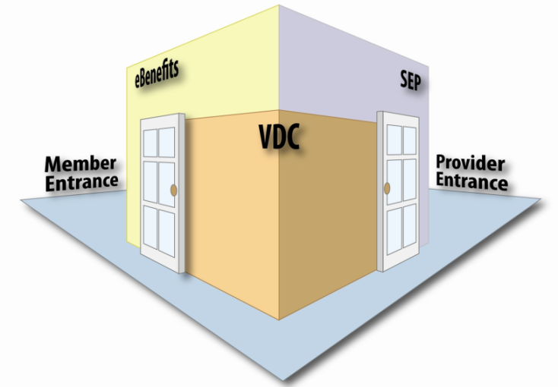

Figure : EVSSP2 combining legacy eBenefits and SEP Portals

The EVSSP2 portal platform also includes the Employment Center (EC). Although EVSSP2 provides the access path to the EC, the EVSSP2 team is no longer responsible for the features developed within the EC Application.

## Purpose of this document

The purpose of the EVSSP2SDD document is to describe in sufficient detail how the proposed system will be constructed to meet EVSSP2 business requirements to include, the forms platform (including VDC and VAP Interface Improvements [VAPii]), eBenefits, SEP, the common Enterprise Content Management System (ECMS). It is also to gain alignment with Reference, Table of Contents, Insert Table of Contents, Modify VA’s infrastructure so that it can be integrated with existing VA and DoD applications.

This document is primarily focused on the technical foundation of the EVSSP2:

* Hardware and software components
* Interaction between components
* Interaction with external systems

## Identification

This document applies to the design and architecture of the Enterprise Veteran Self Service Portal Platform. EVSSP2 is encompasses eBenefits, VDC, and SEP systems with a goal of providing a single platform to serve Veterans’ self-service needs and the needs of the stakeholders that work on their behalf. eBenefits is the Veteran facing self-service portal, SEP is the stakeholder facing portal, and VDC is the forms platform for interview driven wizards. They work in together to create unified business process that can be exposed to the appropriate users.

## Scope

The scope of this document will be limited to design recommendations for components needed to cover functionality. No attempt will be made to design future requirements or roadmap items. Such future scope is taken into account in the architecture capabilities and designs for current functionality are intended to avoid conflicting with expansion requirements. Subsequently, extensibility is a key area of concern for the designs in scope.[1]

In the most basic terms, “scope” encompasses those things which a project seeks to accomplish.[2]

Successful rollout and implementation of EVSSP2 is contingent upon a strong working relationship between the developer and its customer, VA Office of Information Technology (OIT). The main goal of both enterprises in this effort is to deploy a portal that will enable a user to establish an account, access content and information on benefits and health, conduct business electronically relative to the user’s benefits or health with VA and/or DoD, in a secure and usable environment.

Table : Scope Inclusions

| General Scope |  |
| --- | --- |
| Maintaining a web portal that will leverage the hardware and software platform used by VA’s Veterans Information Portal (VIP), hosted at VA’s Austin Information Technology Center (AITC). | ■ |
| Leveraging and integrating existing VA and DoD portals with pertinent information. | ■ |
| Identifying and developing components of the portal framework that will enable the addition and inclusion of new content and functionality in the future by providing core and common functionality and services, as well as standards and guidelines used by the portal. | ■ |
| Developing and deploying identified features and content as part of a portal product. | ■ |
| Set up the infrastructure for SEP. | ■ |
| Enterprise Content Management capability to maintain content. | ■ |
| Provide common style/look and feel/branding services. | ■ |
| Provide Single Sign-on (SSO) capability for users across multiple applications. | ■ |
| Support ability for Veterans Service Organizations (VSO’s) or persons with Power of Attorney to conduct business with the VA on behalf of the Veteran. | ■ |
| Provide integration capabilities for Line of Business (LOB) applications. | ■ |
| Provide up and support interfaces and services to Veterans and Veteran service organizations (VSO) with employment center (EC) capabilities. | ■ |
| Utilize survey tools to measure effectiveness and customer satisfaction. | ■ |

Table : Scope Exclusions

|  |
| --- |
| Excludes |
| The EVSSP2 Portal does not aim to replace existing VA or DoD portals, but seeks to integrate and centralize access to these portals. |
| The EVSSP2 Portal does not aim to supply or replace the production of content stemming from existing portals. |

Table 3 provides a detailed view of the scope of Release 13.1 25 and 13.3 . A full account in even greater detail is described in the R13.25 – 13.31 design and release documents stored in Rational and is not replicated here.

Table Detailed Scope

| Issue key | Summary | Class of Work |
| --- | --- | --- |
| **Release 13.25** | | |
| EPB-4622 | Vets.gov: Support Integration Information Requests for Vets.gov | Feature |
| EPB-4585 | Vets.gov: Create 526 Service Validation Operations | Feature |
| EPB-4579 | Vets.gov: Create 526 Submission Service | Feature |
| EPB-4575 | Vets.gov: Update Document Services to enable document staging and lookup | Feature |
| EPB-4545 | Vets.gov: Create 526 Prefill/Load and Operation | Feature |
| **Release 13.3** | | |
| EPB-4737 | VA Letters: Name formatting Rules | Production Defect |
| EPB-4736 | PCIU and Veteran Profile Page: Name formatting Rules | Production Defect |
| EPB-4670 | Migrate SEP & VDC Clusters to JDK8 / WebLogic 12.1.3 / RHEL 7 - ST B | Platform Improvement |
| EPB-4667 | Migrate SEP & VDC Clusters to JDK8 / WebLogic 12.1.3 / RHEL 7 - Team 1 | Platform Improvement |
| EPB-4666 | Migrate SEP & VDC Clusters to JDK8 / WebLogic 12.1.3 / RHEL 7 - ST A | Platform Improvement |
| EPB-4665 | Migrate SEP & VDC Clusters to JDK8 / WebLogic 12.1.3 / RHEL 7 - Team 4 | Platform Improvement |
| EPB-4664 | Migrate SEP & VDC Clusters to JDK8 / WebLogic 12.1.3 / RHEL 7 - Team 2 | Platform Improvement |
| EPB-4085 | Upgrade ECMS including ECMS Proxy and Alfresco Components to 5.1.1 | Platform Improvement |
| EPB-4692 | Reword user-facing message in PCIU when a '02X - Block Address Change' fraud flag is place on a beneficiary account | Feature |
| EPB-4148 | 21-22 Reduce the Insurance Number field length to 10 characters | Feature |
| EPB-3521 | Enhance search results to use entire dataset in header sort | Feature |
| EPB-3517 | Release Medical Record-Adding Continue/Cancel when continuing instead of being directed to 'Your Personal Information' page | Feature |
| EPB-3032 | Intent to File in Work in Process Page change | Feature |
| EPB-2913 | SEP: Ability to Save a Search in the VSO Work Queue | Feature |
| EPB-2751 | 4142 Form Treatment Records - Make Save and Continue active if navigated back to PI page and then access Treatment Record | Feature |
| EPB-1055 | SSCR-129 Ability to easily order eBenefits carousel items | Feature |
| EPB-4645 | Support Microsoft Edge Browser in Document Upload | Platform Improvement |
| EPB-4529 | Incorrect server side message is displayed for blank Address Line1 field | Production Defect |
| EPB-4419 | 526 DBQs documents are uploading to the wrong section (all are linking to the same DBQ 1st DBQ) | Production Defect |
| EPB-4395 | Primary and Secondary Phone number is displaying on 686 PI page after deleting in PCIU | Production Defect |
| EPB-4336 | VOA link at end of 526 does not go to the VOA application | Production Defect |
| EPB-4324 | Anything entered in the Medal/Citation description box does not show up in PDF | Production Defect |
| EPB-4159 | VSO WQ International search does not return data if searching on one country | Production Defect |
| EPB-4019 | EBN Learn > VRE > login to my account link at the bottom throws 404 error | Production Defect |
| EPB-3593 | Missing Form 9 Date | Production Defect |
| EPB-3296 | Prevent PII Leaks - Correct click event issue | Production Defect |
| EPB-3920 | 526 Document Upload All Done vs Cancel Logic | Production Defect |
| EPB-3602 | Error Check in Release Medical Records (VA Form 21-4142) application isn't requiring all Treatment Source address information | Production Defect |
| EPB-3447 | Clicking the "<" button on the "Search for a Power of Attorney Representative" page fires the server-side input validation incorrectly | Production Defect |
| EPB-4646 | Notify User of Supported Browsers | Platform Improvement |
| EPB-4209 | EBN:No Uploaded Document(s) found for bnft_claim_id | Platform Improvement |
| EPB-3694 | NullPointerException on getClaimDetailById | Platform Improvement |
| EPB-4119 | PaymentHistoryController throws NPE (NullPointerException) in PROD | Production Defect |
| EPB-3835 | GA AJAX Timing: Claim details/Upload Document ajax timing | Performance |
| EPB-3647 | Enhance Veteran Record web service calls to process improved error messages from Partner | Platform Improvement |
| EPB-3314 | Claim Status: Enhance services to process/return improved error messages from Partner | Platform Improvement |
| EPB-4421 | Update VNP Attachment Service to use MTOM | Platform Improvement |
| EPB-4654 | Improve Application Logging in Claims Web Parts | Platform Improvement |
| EPB-4481 | Fortify - Privacy Violations | Platform Improvement |
| EPB-2743 | Icon not showing up in Firefox for VSO Work Queue page in SEP | Production Defect |
| EPB-794 | SSCR-89 UAT-Interactive Char Count for the Text fields | Feature |
| EPB-4653 | Address Low Fortify violations in Common and Claims Webparts | Platform Improvement: Fortify |
| EPB-4727 | DPRIS: Inform eBenefits users that DPRIS will be unavailable after 13.3 release | Production Defect |
| EPB-4710 | Update eFolder Filter to Include Vets.gov as Source | Feature |
| EPB-4417 | SEP: Remove excessive freemarker errors in SEP logs caused by null user agent | Platform Improvement |

## Relationship to Other Plans

The SDD is not a Veterans Information Portal (VIP) required artifact however it is being maintained as a historical artifact only and, is not intended nor will it attempt, to consolidate the VIP required design, requirements, test, deployment and operation documentation maintained in Rational. Further, the valid VIP required artifacts include the follow documents which formally describe the system and release specifics. These artifacts may be located at <https://clm.rational.oit.va.gov/ccm/web/projects/EVSS%20(CM)>

* Sustainment Contracts / Licensing and Funding for EVSS Service Level Agreements and Outside Level Agreements ( SLA's & OLA's) for EVSSEVSSP2Requirements (Epics/User Stories) for EVSS Traceability (requirements to test cases)/Test Execution/Test Results/Defect Log for EVSS
* Release Notes
* Risks for EVSS
* Version Description Document for EVSS
* Production Operations Manual (POM) for EVSS
* Deployment/Installation/Rollback/Back-Out Guide for EVSS
* Authorization to Operate (ATO) for EVSS
* 508 Compliance for EVSS
* User Guides for EVSS
* Deployment artifacts
* Source Code bundle

## Methodology, Tools, and Techniques

The system design follows the VA Veterans Focused Integration Process (VIP) process and the VA Agile development methodology.

Requirements and action items related to the system design will be archived in the VA Rational Team server Suite at <https://clm.rational.oit.va.gov/ccm/web/projects/EVSS%20(CM).EVSSP2>

## Policies, Directives and Procedures

The AITC maintains an incident response capability that supplements the VA program. The AITC ensures an adequate program is in place such that management receives early notification about a computer security incident, ascertains the facts of the situation, makes a damage assessment, determines a priority and a corrective strategy, allocates resources as necessary to ensure an adequate correction within the priority timeframe, assesses responsibility, prepares complete documentation, plans and implements a permanent correction, and modifies procedures or policy as appropriate. These procedures are outlined in AITC Handbook 6500.04, Computer and Network Security Incident Response.

EVSSP2 is required to adhere to the Veterans Focused Integration Process (VIP). All EVSSP VIP artifacts are recorded and maintained within the VA Rational toolset and are approved by VIP Release Agents as required and described in the VIP process. This SDD document is not a required artifact as per the VIP process however, it is being maintained and stored in the Rational tool for historical purposes.

## Constraints

Availability of the web portal and the reliability of its system design are dependent upon a large and ever-growing list of external business partners and stakeholders who act as content providers and portlet integrators into the EVSSP2 system.

Operational and design continuity is dependent upon systems such as VA/DoD Identity Repository (VADIR), Defense Eligibility Enrollment Reporting System (DEERS), the Veterans Benefits Administration (VBA) Share application, Recommender Agents and Adaptive Web-based Systems (RAAWS), and other VA and DoD data repositories.

EVSSP2 system and interaction design is constrained by the integration of its business partners and the flexibility with which they are able to provide content for skinning into the established EVSSP2 content, language, and style.

Forms Platform has been developed within the existing EVSSP2 Portal and must comply with EVSSP2 environment, platform, and design requirements.[3]

Compatibility of portlets with Liferay 6.2 or higher (Community Edition or Enterprise Edition) is also a constraining factor of technical design and integration.

EVSSP2 additionally supports the following integration standards:

* Single Sign On (SSO) - Single Sign On is the ability for multiple applications to pass a user between n the systems without requiring the user to re-authenticate. There are various patterns in the industry, but EVSSP2 only allows integration VA Identity and Access Management (IAM) through the VA Authentication Federated Infrastructure (VAAFI).
* IFrame - In an iFrame, the portlet is a window to the external site where the application resides. The portlet is completely isolated from the eBenefits codebase. This means that, since there is no crosstalk between eBenefits and partner styles or code, the partner is fully responsible for styling the portlet.
* SOAP Web Services - SOAP (Simple Object Access Protocol) provide standards for exchanging structured information, using XML. It supplies a basic messaging framework for building web services, and is platform-independent. In a SOAP integration, the portlet behaves like native eBenefits code and is highly integrated in look, feel, and interactivity.
* WSRP - In a WSRP (Web Services for Remote Portlets) integration, eBenefits and the partner application communicate using WSRP standards. The portlet behaves like native eBenefits code and is highly integrated in look, feel, and interactivity. The partner writes an HTML interface for the eBenefits portal, and the eBenefits CSS and JavaScript will be available to that portlet.
* REST - Representational State Transfer (REST) is a standard integration type for distributed systems. It uses a client/server architecture. Client requests and server responses transfer representations that capture the current or intended state of a resource. REST allows loose coupling between services, while minimizing the addition of new features on top of an existing application. Since REST does not require XML parsing and does not require a message header to be passed to and from a service provider, it uses less bandwidth than its counterpart, SOAP.
* Mobile - Partners work with the eBenefits team to create a mobile version of their feature(s) using responsive layouts that can be accessed through the same interface. The timeline for a mobile integration is similar to that for a desktop portlet integration.

## Design Trade-offs

### EVSSP2

The system will make use of interfaces between internal services and external systems. This will decrease the number of code modules that need to be developed, and will add the following benefits:

* Unbound coupling of technologies, so that changes in external systems will have an isolated effect on the overall portal;
* Unit testable interfaces that can be automated and regression tested using XML documents and plain text (Cucumber) files containing expected test plan scenarios;
* Parallel development accommodated by developing to interfaces;
* Separation of business rules from infrastructure code to allow for more agility with business changes reducing risks of changes to integration code;
* The portal, as a content management system-driven portal, requires content to be surfaced via Alfresco eCMS, with current FreeMarker templates used to help manipulate code;
* The portal requires a portal platform to accommodate core portal features. Liferay Portal is the chosen portal product.
* The portal, requiring data persistence, requires Oracle RDBMS to persist data.
* The portal, being Java based, requires WebLogic Application Server to provide Java runtime.
* The portal, having advanced web routing requirements, requires Apache HTTP to rewrite URLS and handle web traffic routing.
* Integrating many divergent portlets requires “skinning” content to resemble EVSSP2 style sheet.
* Best in class development approach and improved delivery of needed functionality (i.e. time to market) lowers total cost of ownership.
* Flexibility to adapt to mandates for utilization of external technologies and iframing tools e.g., Ruby on Rails, Heroku Forms.
* HTML forms can be written directly within EVSSP2. EVSSP2 supports pre-populating PDF forms with the results and electronically submitting the forms.

## User Characteristics

### System

The system is designed to integrate several separate online customer facing systems into a single portal, allowing for online application for benefits and the ability to manage Veteran claims. Thus users (VA’s Veterans and Dependents (Members) and those providing services on behalf of the Veteran (Providers), known as personas on the EVSSP2 Portal project, are a vital part of the system and interaction design. While the EVSSP2 users are varied, they will break down into two distinct types: unauthenticated users, or public access; and authenticated users. The authenticated users will utilize various systems of federated identity standards to access content that contains personally identifiable information (PII), as well as claims forms and the status of those claims.

Authenticated users will have a personalized workspace that provides quick access to EBN tools. Using EBN tools, a Veteran can complete various tasks, apply for benefits, download a DD 214, and view benefits status, in addition to other actions as needed. Authenticated users can assign proxies to work in their behalf. These proxies, members of Veteran’s Service Organizations (VSO), attorneys, and other agents must also be authenticated into the EVSSP2 system and granted permission to act on the Veteran’s behalf.

Unauthenticated users, otherwise known as public users, will be able to access ‘public content’ via a catalog of links to other sites that provide information about military and Veteran benefits. Employment resources and tools are available to the public via the EC on EBN.

### Forms

The users of this application are Veterans with a Level 2 credential for the DoD Self-Service Logon (DS Logon). The business vision for future increments of the project is to expand the service to extend availability to non-Level 2 DS Logon credentialed users. The second increment of the project expands service to verified credentialed users for Level 1 DS Logon. The availability of service to unverified Level 1 DS Logon credentialed users depends on the availability of the Identity Access Management (IAM) Program to provide authentication for anonymous users.

### User Problem Statement

There is no current system servicing for all of the intended user community. The numerous portals users today are required to navigate in order to access the required information or services.

For the purpose of this SDD, the following is an inventory of current benefit applications. It does not include all of the websites that discuss the benefits to which users are entitled. The complete list will be provided at a later date when the inventory of benefits has been identified for this initiative.

Table : Current Benefit Applications

| Org | Portal name | URL | Purpose |
| --- | --- | --- | --- |
| VA | VA – My HealtheVet | [myhealthevet.va.gov](http://vaww.oed.portal.va.gov/sites/vrm/SS/AppData/Local/Microsoft/Deliverables/AppData/Local/Microsoft/Windows/AppData/Local/AppData/Local/Microsoft/Windows/Documents%20and%20Settings/Matt.Hayes/Desktop/myhealthevet.va.gov) | A gateway to Veteran health benefits and services. |
| VA | Veterans Information Portal (VIP) | [vip.vba.va.gov](http://vaww.oed.portal.va.gov/sites/vrm/SS/AppData/Local/Microsoft/Deliverables/AppData/Local/Microsoft/Windows/AppData/Local/AppData/Local/Microsoft/Windows/Documents%20and%20Settings/Matt.Hayes/Desktop/vip.vba.va.gov) | Links to Veterans’ benefits and services, as well as information and resources for other departmental programs and offices. |
| DoD | Deployment Health Clinical Center | <http://www.pdhealth.mil/family.asp> | Provides related links on healthcare and service member / family support services, especially in relationship to deployments. |
| DoD | TRICARE Online | [www.tricare.mil](http://www.tricare.mil/) ([www.tricareonline.com](http://www.tricareonline.com/)) | Provides access to healthcare tools, services, and resources for beneficiaries, providers, Military Health System (MHS) staff, and external support contractors. |
| DoD | TRICARE | [www.tricare.mil](http://www.tricare.mil/) | Provides access to TRICARE entitlement information and forms, and information about Military Treatment Facilities (MTFs) and external support contractors. |
| DoD | Defense Knowledge Online/Army Knowledge Online | [www.us.army.mil](http://www.us.army.mil/) | Provides mainly personnel information for active duty, reserve, and retired Army personnel. |
| DoD | My Air Force Portal | [www.my.af.mil](http://www.my.af.mil) | Provides mainly personnel information for active duty, reserve, and retired Air Force personnel. |
| DoD | Navy Knowledge Online | [www.nko.navy.mil](http://www.nko.navy.mil) | Provides access to information and resources such as career management, personal development, leadership, learning, reference sources, etc., for active duty, reserve, and retired Navy personnel. |

Veterans and their beneficiaries must print, complete, sign, and mail benefits claims forms to VBA for processing. The claims forms can be difficult to understand and Veterans may need assistance in completing the forms. While the legacy forms platform allows electronic submission of select claims, it still requires VBA claims processors to download paper forms to adjudicate many benefits claims, especially those for C&P benefits. In the current VA claims process, the claim is placed in a paper claims folder (C folder) for the Veteran, and the claim undergoes a paper-based adjudication process. If additional information is required, a Veterans Service Representative (VSR) sends a letter to request the information from the Veteran and the VSR awaits a response before further processing. This paper-based process is time consuming, resulting in an average 167 days to process a claim.

### User Objectives

#### EVSSP2 Users

User objectives for EVSSP2 users are derived from organized user research sessions conducted by the User Experience team. These sessions discuss portal functionality and desired characteristics with the EVSSP2 user population. These user objectives are then discussed with the EVSSP2 Program Release Team lead and the Architecture Review Board as potential roadmap features for later software release cycles.

#### Forms Users

The objectives are to increase access to VA benefits for users, enable Veterans to file online applications for claims anywhere with an Internet connection, and file online applications anytime in an integrated fashion with other VA benefits sites within a secure portal solution. This secured portal will be made available through a federation with external business partners, such as the DoD and Social Security Administration (SSA).

The forms platform should reduce the Veteran, beneficiary, or military service member’s burden of entering and repeating information on multiple forms when applying for multiple benefit. This is accomplished by integrating the forms platform application process with the VA CorpDB and pre-filling information already available from the CorpDB, Beneficiary Identification and Records Locator System (BIRLS), and VADIR. The forms platform leverages existing imaging technology in Virtual VA (VVA) of the Compensation and Pension (C&P) service and The Image Management System (TIMS) of the Education service. An image of the completed applications is sent to these systems based on the business line, which allows access to previously submitted applications and correspondence sent by the applicant or by claims processors.

The forms platform supported VA forms will be updated to add new form support so that legacy VONAPP, VONAPP II, VDC can be decommissioned and replaced with forms platform. The solution also incorporates a forms wizard interface with interview-style questionnaires to assist Veterans in filling out complicated forms.

The forms supported include:

* Dependent Benefits (686c/674)
* Compensation Benefits (21-526ez) – the 526 Forms process will be supported by frontend system access via Vets.gov portal; however, EVSSP2 will continue to provide the backend processes. There is no plan at this time for EVSSP2 to decommission this activity.
* Post-Traumatic Stress Disorder (PTSD) (781/781a)
* Unemployability Benefits (8940)
* Form 4502 Application for Automobile or Other Conveyance and Adaptive Equipment (within the 526 Form under ‘Special Circumstances’ tab)
* Form 2680 Application for Aid and Attendance (within the 526 Form under ‘Special Circumstances’ tab)
* Request for Representatives (21-22 Request for VSO/21-22a Request for Attorney Agent)
* Release of Medical Records (21-4142)
* Disabled Veterans Application for Vocational Rehabilitation (28-1900)
* Educational/Vocational Counseling Application (28-8832)

# Background

## Overview of the System

The scope for the EVSSP2 integration is to not replace all VA and DoD portal activities, but to initially leverage and integrate existing portals/websites and forms. This infrastructure will also be the platform to integrate self-service applications and other online services. The interface design goal is to give users a central access point to online services with improved information architecture. It should be noted that the architecture of the EVSSP2 system will maintain the capability of supporting additional future user types, as well as unique access requirements.

Role-based access control, in conjunction with identity management, and other solutions lays the foundation for providing personalized information and services. Enabling personalization and customized access to content, services, and applications related to benefits is an important operational component of the EVSSP2. This strategy proves invaluable to users, who are be able to find tailored benefit information and services in one place, rather than scattered across websites and access channels.

The end result is a website/portal that will offer enhanced services to Veterans and military service members and service providers at lower costs. An improved and positive online experience encourages users to come back and use more online services, which will retain and expand the online user base. The usage growth through the web channel also implies a decline in other conventional, labor-intensive, higher-cost information resource channels. This trend could also be interpreted as an opportunity to reallocate resources away from information management and more toward benefit processing. Most importantly, it will allow users to find the information and services they need, when they need it.

The forms platform enables service members to apply for compensation benefits and/or pension benefits, as well as vocational rehabilitation benefits. For example, veterans and service members with two years of service, and members of the Selected Reserve can apply for education benefits**.**[4]

Table 5 **lists the stakeholders for the EVSSP2.**

Table : Stakeholders

| Company | Name |
| --- | --- |
| BGS | John Dell |
| Data Architecture | Jack Goldberg Jeffery Voivoda (Acting for Jack) Dave Collins Jian Ouyang |
| VAAFI | Steve Zullo,  Jeff Kemple,  Jerry Wharton,  Courtney Rive |
| VHA | Michelle Rowe, Denise Kitts, |
| DMC | Jodi Thompson Reviewer Noah Swerin |
| OBPI | Approver Kristine Adamo Bruce Crowell |

## Overview of the Business Process

EVSSP2 encompasses several business processes within its system. The following is a basic outline of the major business processes inherent in its daily operation.

* **Deliver personalized content pages**
  + CMS
  + Content queries
  + User profiles
* **Consume business applications and services from other areas**
  + SSO
  + WSRP
  + Simple Object Access Protocol (SOAP) Web Services (WS)
  + Java Database Connectivity (JDBC)
  + HTML Inline Frames (iFrames)
* **Provide business applications and services for consumption by others**
  + WSRP
  + SOAP WS
  + Representational State Transfer (REST) WS

Figure 2 shows at a high level that this process consists of six process groups, which includes Account Setup, Benefits Application, Validation, Submission Claimant Notification, and Approvals, along with the steps applied across the groups. Additionally, forms platform business processes are illustrated.



Figure : Forms Platform Business Processes Diagram

As shown in Figure 2, the user sets up an account and a user profile is generated and attached to that account. The user then selects an application for benefits and is presented with an interview-driven process. Known information from the profile is populated in the appropriate areas of the interview process for the user, with the user entering unique information when requested. After the user completes the application, the user submits it for verification. If verification fails, the user is returned to the process to correct the information. After the validation process is complete, the form can be submitted for processing. After successfully submitting the form, the user is notified by the system that the application has been submitted successfully. This information also includes the regional office (RO) location where the application was transmitted.

## Business Benefits

This system is designed to address the following business problems:

* Users must understand DoD and VA organizational structures in order to find pertinent information.
* Information is scattered across multiple portals with different credentials.
* Each portal has different navigation, interface, and user requirements.

EVSSP2 is designed to:

* Be user-centric.
* Remove the need for knowledge of the DoD and VA organizational structure by collecting all information in one location.
* Make all services unified under one interface, with one credential for everything.



**Realizing EVSSP2 vision**

Figure : The Unified Interface

The business benefits for applicants include a significant decrease in the amount of time to apply for Veteran’s benefits. The forms platform increases accuracy of information that in the past would have significantly delayed benefits administration. The system unites information from Veterans into a unified portal that reduces the administrative burden on VSRs, while also improving staff knowledge of health benefits for Veterans. Additional business benefits expected to result from the forms platform include the following:

* By guiding users through a series of logical interview questions to request benefits, user experience and accuracy improves.
* All claims are submitted electronically (reducing submission time) and stored automatically in an electronic format in a VA database.
* Claim submission generates a work item that is assigned to a VSR to process, ensuring that the claim is addressed in a timely fashion.
* Claims are maintained in electronic form, allowing the claim to be processed anytime, anywhere, which reduces/eliminates paper storage costs of forms.
* Veterans are able to check the status of their claim online at any time during the process.
* Pre-filling of information into forms reduces the time needed to fill out the forms and increases the accuracy of the information in the forms.

## Design Assumptions, and Constraints

The system design assumes that all production systems integrating with EVSSP2 will use standardized web and Java languages and secure transfer security layers in accordance with VA and DoD standards.

EVSSP2 is required to adhere to the VA Enterprise Architecture and , the VA VIP standards and is reviewed and approved by the VIP Release Agent.

### Design Assumptions

Other assumptions include:

* Business rules will be agreed upon and vetted with EVSSP2 stakeholders prior to release.
* System architecture for custom portal builds will be mutually agreed upon by the system architects from both EVSSP2 and its integration partner.
* At minimum, the portlet should support Internet Explorer (IE) 6+ and Firefox 1+.
* Compatibility (the portlets should support Liferay 6.2 or higher - Community Edition or Enterprise Edition)
* HTML forms allow complete adoption of cutting edge Web technologies including multimedia support.
* HTML forms support all common interfaces to Java products for CRM, chat, analytics, and other interfaces.
* HTML forms are more capable, but come with more complexity per unit. Strategies for Web content management supplied by EVSSP2 CMS shorten turn‑around cycles.
* Existing features in EVSSP2 require no new development to enable forms.
* HTML forms achieve more flexibility through more moving parts.
* The first forms can be completed in weeks.
* HTML forms require knowledge of the EVSSP2 platform and require coordination at a finer-grained level.
* Wizard development can be developed by HTML and JavaScript developers.
* HTML forms require a functional EVSSP2 environment.
* HTML forms rely on the same security as other EVSSP2 features.
* HTML forms support and comply with Section 508 requirements.
* HTML forms support mobile versions of all features with minimal extra work.
* HTML forms require no additional components.
* Long term, PDFs are not required at all. Electronic signatures can be captured after viewing HTML-formatted summary screens.
* The HTML form approach uses 100% standard Java and Web technologies and can be repurposed to any Java container and supporting hosting environment..
* Overall, HTML forms cost significantly less to implement.

### Design Constraints

The system is expected to be fully automated, so no additional user interface is expected for the end-user. The users should not have to learn any different front-end application other than those which they already use. All outputs are expected to appear in systems already in use. For this reason, WSRPs and HTML iFrames will be used as much as possible for any outputs and existing Corporate Database tables will be the final target of any decisions made by the system.

The forms platform aspect is expected to be user-facing. This functionality enables the user to provide information associated with the processes of (1) adding a dependent and (2) verifying continuation of a dependent in school. For this reason, WSRP and HTML iFrames are used as much as possible for any user interaction, and existing and new tables in the VA CorpDB are the final target for data collected by the system.

## Overview of the Significant Requirements

This section provides an overview of the major functional requirements for the system.

### System Overview of Significant Functional Requirements

The significant functional requirements of the EVSSP2 system are laid out in the Software Requirements Specification documentation. See the SRS for additional information about the functional requirements for the EVSSP2 system.

### Forms Platform Overview of Significant Functional Requirements

The following information is used as an example of the functional requirements for completing various forms through the forms platform.

The forms supported include:

* Dependent Benefits (686c/674)
* Compensation Benefits (21-526ez)
* Post-Traumatic Stress Disorder (PTSD) (781/781a)
* Unemployability Benefits (8940)
* Form 4502 Application for Automobile or Other Conveyance and Adaptive Equipment (within the 526 Form under ‘Special Circumstances’ tab)
* Form 2680 Application for Aid and Attendance (within the 526 Form under ‘Special Circumstances’ tab)
* Request for Representatives (21-22 Request for VSO/21-22a Request for Attorney Agent)
* Release of Medical Records (21-4142)
* Disabled Veterans Application for Vocational Rehabilitation (28-1900)
* Educational/Vocational Counseling Application (28-8832)

**General Information Processing Rules:**

1. If the user is not authorized to access EVSSP2—i.e., all users who are not Veterans who are in-person proofed, DS Logon Level 2—display the “About page.”
2. For Service Members, only display the link under My EVSSP2 for Veterans who have a 30% disability rating, with a current running award in VETSNET (not available for Benefits Delivery Network [BDN] claims).
3. If 2 and 3 are true, then display link under My EVSSP2 🡒 Compensation “Add a Dependent.”

**General Information:**

1. Display the following information from VA CorpDB:
2. Veteran’s Name
3. Social Security number (SSN)
4. File Number
5. Current Mailing Address
6. E-mail Address
7. Primary Phone Number
8. Secondary Phone Number
9. Gender
10. Date of Birth
11. Display message to user: **If any of the following information is incorrect, use the “Edit” option to make changes.** Allow the following fields to be edited:
12. Veteran’s Name
13. Current Mailing Address
14. E-mail Address
15. Primary Phone Number
16. Secondary Phone Number
17. Gender (if blank)

**Request for Approval of School Attendance:**

1. Display message to user: **Please enter student’s personal information:**
2. What is the student’s name?
3. What is the student’s Social Security number (SSN)?
4. What is the student’s date of birth?
5. What is the student’s address?
6. Has the student ever been married? (If yes, display follow-up question. If no, continue to #8.)

* When was the student married?

1. Is student enrolled in a full-time high school or college course? (If no, display follow-up questions. If yes, continue to #9.)
2. What is the student’s subject of study? (If other than full-time high school or college course.)
3. What is the date the student started or expects to start this course?
4. What is the student’s expected date of graduation?
5. Was the student attending any school at the end of the last school term? (If yes, display follow-up questions.) If no:
6. What is the name of the school?
7. What is the address of the school?
8. What is the number of sessions per week?
9. What is the number of hours per week?
10. When is the beginning date of the student’s last term?
11. When is the ending date of the student’s last term?
12. Display the following question to the Veteran: **Is tuition and/or allowance for this student’s education or training being paid by VA Dependents Educational Assistance (DEA), the Federal Employees Compensation Act or any other agency or program of the United States government?** (If yes, display follow-up questions. If no, continue to #9.)
13. What is the name of the agency?
14. What is the date the payments from this agency began?
15. Display message to user: **Please enter current school information.**
16. What is the name of the school?
17. What is the address of the school?
18. What is the name or type of the student’s course of education or training?
19. What is the official beginning date of the regular term or course?
20. What is the date the student started or expects to start the courser?
21. What is the student’s expected date of graduation?
22. Display message to user: **Please enter the student’s income and net worth information. ‘Received’ means amount received for the year in which term begins. ‘Expected’ means amount expected for the following year. If none please enter ‘0’.**
23. What are the earnings from all employment? (received and expected)
24. What are the earnings from annual Social Security? (received and expected)
25. What are the earnings from other annuities? (received and expected)
26. What are the earnings from all other income (e.g., interest, dividends, etc.? (received and expected)
27. Display message to user: **Please enter the value of the student’s estate. If none please enter ‘0’.**
28. What is the value of the student’s savings, including cash?
29. What is the value of the student’s securities, bonds, etc.?
30. What is the value of the student’s real estate (not your home)?
31. What is the value of the student’s other assets?
32. Display message to user: **If any of the following information is incorrect, use the “Edit” option to make changes.** Allow the following fields to be edited:
33. Veteran’s Name
34. Current Mailing Address
35. E-Mail address
36. Primary Phone Number
37. Secondary Phone Number
38. Display message to user: **Please select marital status:**
39. Married
40. Divorced
41. Widowed
42. Separated
43. Never Married
44. Display the following question to the Veteran: **What would you like to do today?** Allow the Veteran to select only one option.
45. Add a spouse
46. Add a child
47. Add both – spouse and child

**Add a Spouse:**

1. If “Add a Spouse” is selected and if a current spouse exists, display the spouse’s:
2. Spouse’s Name (Last name, Middle name, First name)
3. Spouse’s SSN (xxx-xx-xxxx)
4. Spouse’s DOB (mm/dd/yyyy)
5. Display the following question to the Veteran: **Is the information correct?** If ‘Yes’ is selected, then ‘Add a Spouse’ process ends.
6. If the Veteran selects ‘No’ to 9 or if no current spouse exists, then prompt the Veteran to enter the following information by displaying the following question and fields:

**Enter your spouse’s information:**

1. Spouse’s first, middle, and last names (Required)
2. Spouse’s SSN (Required)
3. Spouse’s date of birth (Required)
4. Display the question to the Veteran: **When were you married?** (Calendar function)
5. Display the question to the Veteran: **Where were you married?** (City, State, or Country)
6. Display the question to the Veteran: **Is your spouse also a Veteran?** (Required) (If no, display question 14. If yes, display follow-up question):

* “What is your spouse’s VA file number (if any)?” (Required if answer to #13 is yes.)

1. Display the question to the Veteran: “Do you live with your spouse?” (Required) (If yes, Add Spouse process completed. If no, display follow-up questions:)
2. “What is your spouse’s address?” (Required if answer to #14 is no.)
3. “How much do you contribute monthly to your spouse’s support?” (Required if answer to #14 is no.)
4. Display the question to the Veteran: **How many times have you been married (including current marriage)?** (Required). If Veteran states he/she has previous marriages (select/enter “2” or more), request the following information for each previous marriage (all required if Veteran has previous marriages) by displaying the following questions:

**“Enter information about your previous marriage:”**

1. “To whom were you married?” (Last name, Middle name, First name)
2. “When were you married?” (Calendar function)
3. “Where were you married?” (City, State or Country)
4. “How did your marriage end?”
5. “When did your marriage end?” (Calendar function)
6. “Where did your marriage end?” (City, State or Country)

<Repeat until all previous spouse information in entered.>

1. Display the question to the Veteran: **How many times has your current spouse been married (including current marriage)?** (Required). If Veteran states his/her spouse has previous marriages (select/enter “2” or more), request the following information for each previous marriage (all required if Veteran’s spouse has previous marriages) by displaying the following questions:

**“Enter information about your spouse’s previous marriage:”**

1. “To whom was your spouse previously married?” (Last name, Middle name, First name)
2. “When was your spouse previously married?” (Calendar function)
3. “Where was your spouse previously married?” (City, State, or Country)
4. “How did your spouse’s previous marriage end?”
5. “When did your spouse’s previous marriage end?” (Calendar function)
6. “Where did your spouse’s previous marriage end?” (City, State, or Country)

<Repeat until all previous spouse information in entered>

1. Add Spouse complete. Return to Add a Dependent screen.

**Add a Child:**

1. If “Add a Child” is selected and if child/children already exist, display child’s/children’s:
2. Name(s) (first, middle, last)
3. SSN
4. Date of birth (month, day, year)
5. Display the following question to the Veteran: **Is the information correct?** If ‘Yes’ is selected, then display the question: **Do you want to add another child?** If ‘Yes’ is selected, then display question 19. If ‘No’, “Add a Child” process ends.
6. If ‘No’ is selected in the previous step and If “Add a Child” is selected, prompt the Veteran to enter the following information (All required):
7. “What is your child’s name?” (Last name, Middle name, First name)
8. “What is your child’s date of birth?” (mm/dd/yyyy)
9. “Where was your child born?” (City, State, or Country)
10. “What is your child’s Social Security number (SSN)?” (xxx-xx-xxxx)
11. Select child status (only one): **Note:** If any child is claimed as “seriously disabled,” it must be shown that the child became permanently unable to support him/herself before reaching age 18. Furnish a statement from an attending physician or other medical evidence that shows the nature and extent of the physical or mental impairment.

* Biological
* Adopted
* Stepchild
* 18-23 Yrs Old and In School
* Seriously Disabled
* Child Previously Married

1. Display the question to the Veteran: **Does this child live with you?** (If ‘Yes’, “Add a Child” process complete. If ‘No’, prompt Veteran to provide):
2. “What is your child's complete address?”
3. “What is the name of the person with whom your child lives? (If applicable)”
4. “Add a Child” complete. Return to Add Dependent screen.

The following additional specifications were derived from the first iteration of the forms platform effort, in which a Functional Requirements Document (FRD) was produced. The historical requirements listed in Table 6 address the comprehensive, long-term vision for the system. The FRD from this first iteration of the forms platform was initially accepted by the government as a formal deliverable in February 2009. However, as the system later underwent multiple revisions, it became apparent to the various project stakeholders that significant issues existed regarding the quality of the requirements set. While the quality of these requirements is inconsistent, they provide value—not as binding or formal specifications—but instead as inputs to the current and future increments. During the requirements analysis phase of each incremental cycle, these historical requirements are reviewed and decisions are made regarding which requirements remain valid and should receive a high priority, and which ones are low priority or no longer valid. The requirements analysis efforts in future increments will also generate new, detailed requirements specific to the scope of each respective increment; however, these historical specifications may be subject to change. Table 6 lists the functional (historical) requirements.

Table : Functional Historical Requirements

| ID | Specific Requirement/Synopsis |
| --- | --- |
| FNC.001 | FORMS PLATFORM shall be a Web-based application. |
| FNC.001 | FORMS PLATFORM shall be browser neutral. |
| FNC.003 | FORMS PLATFORM shall adhere to the existing accessibility Section 508 guidelines. |
| FNC.004 | A user shall be able to access FORMS PLATFORM from the www.va.gov website via a government portal. |
| FNC.007 | FORMS PLATFORM shall be able to display an administration menu. |
| FNC.015 | FORMS PLATFORM shall include with each attachment the indexing values that need to be sent in the .csv file to TIMS or Virtual VA. |
| FNC.035 | FORMS PLATFORM shall enable users to preview/print a form at any time to provide users with a hardcopy of a partially completed form. |
| FNC.035 | When a user selects the print option, FORMS PLATFORM shall display a pop-up message that informs a user that the electronic application has not been completed. |
| FNC.035 | When the form has been submitted electronically, FORMS PLATFORM shall add the following information to the printed copy of the form: date, military time, confirmation number, office location submitted, and the following statement: Submitted electronically via FORMS PLATFORM. |
| FNC.036 | FORMS PLATFORM shall enable a user to save and exit any time while completing a form. |
| FNC.037 | FORMS PLATFORM shall save the data entered into a form to enable the user to complete the form upon their return. |
| FNC.039 | FORMS PLATFORM shall enable a user to print a hardcopy of a submitted form. |
| FNC.040 | FORMS PLATFORM shall enable a user to view all completed forms prior to their submission. |
| FNC.040 | FORMS PLATFORM shall enable a user to view all forms following their submission. |
| FNC.041 | FORMS PLATFORM shall enable a user to delete an entire form that has not been submitted. |
| FNC.045 | FORMS PLATFORM shall enable a user to review their historical information upon subsequent logins. |
| FNC.046 | FORMS PLATFORM shall enable a user to print blank VA forms that it supports. (See the associated note.) |
| FNC.048 | FORMS PLATFORM shall store incomplete form information for 30 days. |
| FNC.049 | When a completed form has been submitted, FORMS PLATFORM will display a Print button to the user. |
| FNC.049 | The Print button shall enable a user to print a hardcopy of the completed form. |
| FNC.049 | When a hardcopy is printed, the printed copy will contain a date/time stamp for when the printing occurred. |
| FNC.049 | When FORMS PLATFORM has finished collecting responses to the form questions, it shall display an Attachments button to the user. (See the associated notes.) |
| FNC.049 | The Attachments button shall permit the user to attach supporting documents to the request form. |
| FNC.049 | FORMS PLATFORM shall display an Attachments button on other screens presented to a user while they are completing a benefits request. |
| FNC.050 | FORMS PLATFORM shall enable a user to print the content of all flash screens. |
| FNC.051 | FORMS PLATFORM shall enable sending a hardcopy letter out via US Postal Service. (See the associated note.) |
| FNC.052 | FORMS PLATFORM shall enable a user to attach electronic file attachments to benefits request submittals. |
| FNC.053 | FORMS PLATFORM shall enable a user to attach multiple attachments to a benefits request. |
| FNC.054 | FORMS PLATFORM shall provide a list of the supporting documents relevant to each form on the attachment page. |
| FNC.055 | FORMS PLATFORM shall include each attachment individually with the submitted form. (See the associated note.) |
| FNC.055 | FORMS PLATFORM shall convert each attachment to a PDF prior to electronic submittal to Virtual VA. |
| FNC.055 | FORMS PLATFORM shall include with each attachment the indexing values that need to be sent in the .csv file to TIMS or Virtual VA. (Note: this duplicates FNC.55) |
| FNC.056 | FORMS PLATFORM shall accept an electronic attachment as large as 5 MB but no larger. (See the associated note.) |
| FNC.057 | FORMS PLATFORM shall store the attachments with the applicable VA form that was submitted for subsequent review by the user. |
| FNC.058 | FORMS PLATFORM shall display to the user an approved fax line for any hardcopy C&P attachments submitted and may be displayed in Virtual VA. |
| FNC.059 | FORMS PLATFORM shall display to a user a list of acceptable methods of submitting hardcopies. |
| FNC.060 | For forms that do not require a wet signature, FORMS PLATFORM shall provide a signature checkbox for the user to click. (See the associated note.) |
| FNC.060 | The signature checkbox shall include a sentence that informs the user that clicking the checkbox certifies that the information they provided is accurate. |
| FNC.061 | For forms that require a wet signature, FORMS PLATFORM shall only enable a user to print the completed form. |
| FNC.061 | For forms that require a wet signature, FORMS PLATFORM shall display the following message to the user prior to submission: The document requires an actual signature and that the user can print the signature page, sign, scan and upload/attach it to the current document which will aide in claims processing timeliness. User will be able to either then print the signature page as indicated above or bypass the message and submit the document without the required signature. If the user bypasses printing the signature page, he/she will be advised to mail or fax the signature page to the appropriate VA Regional Office. |
| FNC.062 | For a form that includes a witness signature block, FORMS PLATFORM shall, via workflow, enable a user to provide an electronic signature via a checkbox. (See the associated note.) |
| FNC.062 | For a form that includes a witness signature block and after the user has identified the witness, FORMS PLATFORM shall route to form, to a witnesses “inbox” for them to provide an electronic signature. |
| FNC.071 | SM lives West of Mississippi CPS -> San Diego 377 |
| FNC.071 | Countries in Asia and Australia -> West |
| FNC.071 | Countries in Africa -> East |
| FNC.071 | Countries in Middle East -> East |
| FNC.071 | Countries in South America -> East |
| FNC.071 | Greenland and Iceland -> East |
| FNC.071 | Armed Forces Americas (AA) -> East |
| FNC.071 | Armed Forces Europe (AE) -> East |
| FNC.071 | Armed Forces Pacific (AP) -> West |
| FNC.071 | American Samoa (AS) -> West |
| FNC.071 | Fed States Micronesia (FM) -> West |
| FNC.071 | Guam (GU) -> West |
| FNC.071 | Marshall Islands (MH) -> West |
| FNC.071 | Northern Mariana Is (MP) -> West |
| FNC.071 | Philippines (PI) -> West |
| FNC.071 | Palau (PW) -> West |
| FNC.071 | U.S. Minor Outlying Is (UM) -> West |
| FNC.071 | U.S. Virgin Islands (VI) -> East |
| FNC.071 | FORMS PLATFORM VA Form 21-526 claims for compensation and pension and for pension only will continue to be marked for routing as they currently are in the FORMS PLATFORM legacy system. (CR 264) |
| FNC.100 | FORMS PLATFORM shall have a location outside the portal where a user can read program requirements before entering the application. (See the associated note.) |
| FNC.101 | FORMS PLATFORM shall enable a user to update the information about FORMS PLATFORM and its capabilities. |
| FNC.101 | FORMS PLATFORM shall enable a user to add to the information about FORMS PLATFORM and its capabilities. |
| FNC.102 | FORMS PLATFORM shall enable a VBA user to edit informational screens. (See the associated note.) |
| FNC.102 | FORMS PLATFORM shall enable a VBA user to edit FAQs button information. |
| FNC.103 | FORMS PLATFORM shall maintain a list of forms that it will enable users to print as blank forms. |
| FNC.103 | FORMS PLATFORM shall enable a VBA user to toggle printing features at the form level. (See the associated note.) |

### EVSSP2 Overview of Operational Requirements

The EVSS operational requirements are based VA policy as identified VA handbook 6500 and the following:

* Performance
* Availability
* Security
* Scalability
* Maintainability
* Accessibility
* Deployment
* Extensibility

Performance pertains mainly with traffic behavioral patterns, established SLAs and expected response times. Further, bandwidth, footprint, network capacity, server traffic, utilization, resource consumption and application constraints where all considered for this release.

R13.1 does not have a significant impact on current design, infrastructure and operations. We completed CPE assessments, including SEDR15-1224 and also our ASSESS for R13.1.

SEDR Status is approved with a valid authorization to operate(ATO) which is kept current and is maintained in the EVSS Rational Team Server suite at URL https://clm.rational.oit.va.gov/ccm/web/projects/EVSS%20(CM)

The program leverages VA approved tools for security, this includes HP Rational Application Scan for to clear our vector, intrusion and penetration attacks as well. In addition, HP Fortify is leveraged to verify security standards are followed as part of the EVSSP2 continuous integration approach.

### EVSSP2 Overview of Functional Requirements

The EVSSP2 functional requirements are tracked in rational software using unique identifiers. The conceptual high level functional requirements are defined in Figure 4. The specific scope of the functional, as well as technical, requirements is also described in the scope for the release which is in Section 1.3 of the SDD.

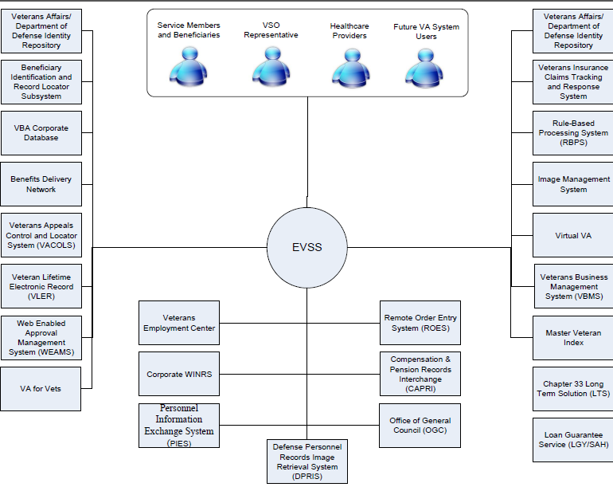

Figure : EVSSP2 Diagram

### EVSSP2 Functional Workload and Functional Performance Requirements

The EVSPP platform is compliant with the IT Infrastructure Standards. Table 7 provides the significant functional workload and functional performance requirements for the system:

Table : Functional Workload and Performance Requirements

| EVSS Subsystem | Transaction Rate (assumed) | Response Time Goal (suggested) |
| --- | --- | --- |
| EBN | 1000 txs/min | 10 sec |
| SEP | 15 txs/min | 8 sec |
| VDC | 120 txs/min | 6 sec |

Metrics are from the EVSSP2 Key Performance Requirements (KPIs) Goals document (July, 2014)

### **Overview of the Security or Privacy Requirements**

Table : Privacy Requirements

| ID | Requirement |
| --- | --- |
| Protection of Personal Identifiable Information (PII) | EVSSP2 Privacy Impact Assessment (PIA) - This document explains what information is collected, used, disseminated, or maintained in the system; how it is collected; and what it is used for. It also explains how it is protected and its accuracy is maintained. |
| Operational Security Requirements for the VA | VA Directive 6500 Handbook - This handbook provides the specific procedures and operational requirements to implement VA Directive 6500, Information Security Program, to ensure Department-wide compliance with the Federal Information Security Management Act (FISMA) of 2002, 44 U.S.C. §§ 3541-3549, and the security of VA information and information systems administered by VA or on behalf of VA. |
| Incident Response | Incident Response Plan – This document outlines what steps are taken in the unlikely event there is a breach in the systems or applications that are housed at the VA in Austin, TX. |
| EVSSP2 Portal (EBN) Application Contingency Plan | EVSSP2 Portal (EBN) Application Contingency Plan – This SDD only slightly addresses the EBN Application Information System Contingency Plan (ISCP) due to the high security classification of that topic content. Please refer to the “Department of Veterans Affairs (VA), Enterprise Operations (EO), Data Center Operations (DCO), Austin Information Technology Center (AITC) eBenefits Portal (EBN) Application Information System Contingency Plan (ISCP)” for detailed information. |
| Security of Electronic Connections | VA Directive 6210 – This document outlines the guidelines for agencies to connect to the VA infrastructure using SS< IPSec and encryption. |

Because the forms platform exists within the EVSSP2, it will attain system security to control access through EVSSP2 where user credentials are captured and passed thereafter to the forms platform for processing.

From a security perspective, there are two major parts:

* Access Control ‑ The entrance into the trusted VA network environment.
* Functionality Availability ‑ The control of access permissions to various components and functionality within the forms platform (covered in part by authentication level identified at the portal and by the forms platform internal procedural controls).
* The following sections explain security in more detail. Not all security controls are covered in this section. Only a subset of the 800-53 controls is covered. The applicable National Institutes of Standards and Technology (NIST) controls are addressed in the System Security Plan (SSP) and Certification and Accreditation (C&A) process.

**Public Users**

Public users of the forms platform currently include Veterans and their dependents and/or their authorized representatives. Generally, users navigate to EVSSP2 through another public-facing Internet site, such as <http://www.va.gov>. One of the goals is to have Veterans register only once on the portal when requesting or gaining access to their benefit information.

The va.gov site will direct users who file for benefits to the landing page for the EVSSP2. This page navigates the user to a logon or registration page.

After the user navigates to the portal landing page, two scenarios are possible:

* The user has never used EVSSP2.
* The user has used EVSSP2 on one or more previous visits.

If the user has never used EVSSP2, the user is asked to register with the portal. Successful registration means an authenticated user who is logged at Level 2 access or greater or an unauthenticated user known to the portal. If the user is authenticated, the forms platform pre-fills data for this person’s selected forms. If the user is unauthenticated, the user still has access to the same processes within the forms platform; however, data is not pre-filled for the selected forms. Instead, the user fills out all necessary data fields.

Additionally, if the user used EVSSP2 on a previous occasion, this user logs on the portal using a previously established username and password. After the user has logged onto the portal, the user has the opportunity to select from a number of applications (portlets). The “Apply for (My) Benefits” forms platform portlet is rendered for all registered users.

After a user successfully logs onto the portal, the content is served up as Java Specification Request (JSR) 168-ompliant portlets. One of the portlets landing portlet that displays some general information on forms platform and a link to access the forms platform. When a user clicks the link for the forms platform, the application opens in an iFrame in the portal context.

The top-level portal navigation is retained and the rest of the portal space is occupied by the forms platform. As an alternative, the forms platform portlet may be opened in a separate window.

For more information regarding the landing page for the EVSSP2 Portal, refer to the Technical Design Document for the EVSSP2.

**Portal Authentication Process**

The portal supports an authentication process using a login ID and password. EVSSP2 is designed to support users external to the organization (Veterans, Service Members, dependents, among others) who can be authenticated on the portal using the IAM security technology.

The portal authentication process is based on a registration process that attempts to match a user to a record in a VA/DoD repository. The portal enforces a strong password and features for lost username and password and resetting passwords.

**Security**

Security is pervasive through all layers of the portal. Security has multiple aspects:

* SSO ‑ Propagation of credentials from other providers according to a shared standard
* Authentication ‑ Identification of a user and assignment of roles
* Authorization ‑ Allowing and disallowing access to secure assets based on user roles

**Authentication**

Authentication is performed using WebLogic “Authentication Providers.” This approach is simple and supports having multiple user stores over time. Initially, there are two user stores:

* Users ‑ Authenticated over SSO with the username/password not stored locally.
* System Lightweight Directory Access Protocol (LDAP) ‑ WebLogic LDAP is used to administer privileged users: administrators, content authors, and content approvers.

**Authorization**

EVSSP2 will use roles to control access to secured resources. Roles will be assigned to track the three important criteria EVSSP2 will use to assign access:

* Credential Level – Level of the credential signifies the risk a user is misidentified.
* Credential Provider – Name of the originator of the credential.
* User Type – User type segments the user supported in functional roles and operations.[5]

### EVSSP2 - Application Information System Contingency Plan (ISCP) – General

To facilitate planning and depict plan relationships, the AITC utilizes four plan types, each with a related template. The four plan types are:

1. **Business Recovery Plan** – This plan is typically prepared by a program manager responsible for one or more lines of business such as acquisitions, human resources, budget and finance, or other office-related business functions. The emphasis of business recovery plans is to maintain major business functions, such as, in the case of human resources: staffing and recruitment, position classification, employee benefits, etc. Business recovery plans, where applicable, should point downward to one or more application recovery plans when that line of business utilizes computer applications in support of business operations.
2. **Application Recovery Plan** – This plan is typically prepared by computer application owners. Typically, these are information technologists responsible for the design and/or maintenance of individual business applications, such as an automated payroll system or an automated human resources application. Application recovery plans include all information technology (IT) hardware and software that is 100% dedicated to a single application. IT resources that are shared among two or more computer applications are covered under Shared Infrastructure Recovery Plans (see [3] below). Application recovery plans shall point downward to one or more Shared Infrastructure Recovery Plans and the AITC ReCOOP Plan (see [4] below). Application Recovery Plans shall point upward to one or more governing Business Recovery Plans when applicable.
3. **Shared Infrastructure Recovery Plan** – This plan is typically prepared by information technologists responsible for the management of shared IT resources such as enterprise software utilities, enterprise storage or backup systems, enterprise security systems or similar hardware or software systems supporting two or more applications (see [2] above). Shared Infrastructure Recovery Plans shall be linked downward to the AITC ReCOOP Plan (see [4] below) and point upward to one or more Application Recovery Plans (see [2] above).
4. **AITC ReCOOP Plan** – The AITC Reconstitution COOP plan (ReCOOP) is prepared by the Director, Service Delivery Management in conjunction with business process owners, IT specialists, facility managers and others. The ReCOOP plan consists of two major functions. Further, the detailed Application Information System Contingency Plan, as well the Disaster Recovery and Contingency Operations Plan (DR/COOP) requirements are a “Security Classification – High” and may not be stated in this unclassified document. Please refer to \\vaaacfpc1\COOPGold\AITC Master COOP.docx.

The first function is to provide an operable computer room that supports Shared Infrastructure and Application Recovery Plans. Infrastructure includes computer room space; power; utilities; backup power systems and network distribution systems such as UPS systems, generators, power distribution units, punch down closets, and computer room HVAC equipment. In order to provide a clear line of demarcation, the ReCOOP plan ends at the power distribution unit and the network punch down closet points of demarcation. Power and connectivity beyond those points are included in Application Recovery Plans and/or Shared Infrastructure Recovery Plans.

The second function is to provide usable space for non-IT functions or IT functions that are performed outside a computer room. This space includes office space, conference rooms, vending and break areas, copier rooms and other space typically found in an office environment. For planning purposes, the ReCOOP plan includes office furniture, telephones, personal computers and all related power and cabling to provide ready-to-occupy workstations for one or more employees. Any specialty equipment required for business operations by a business function (i.e. high speed scanners, large volume printers, microfiche machines) shall be included in individual Business Recovery Plans (see [1] above). The AITC ReCOOP Plan shall point upward to one or more Shared Infrastructure Recovery Plans (see [3] above) and/or one or more Application Recovery Plans (see [2] above).

Thus, where AITC is totally responsible for a business function and all associated applications, shared infrastructure and office/computer room space the planning relationship is as shown in Figure 5.



Figure : EVSSP2 Diagram

The Information System Contingency Plan (ISCP) establishes procedures to recover AITC’s EBN

application following a disruption. EBN is designated as Routine Support for disaster recovery. This level of support will acquire replacement processing capacity after an AITC disaster declaration. The recovery time objective (RTO) is to be operational when the AITC resumes regular processing services or no later than 30 days after a disaster declaration. The recovery point objective (RPO) is 24 hours and data will be restored from the last backup.

Related information security plans (ISCPS) are:

* AITC Master COOP - \\vaaacfpc1\COOPGold\AITC Master COOP.docx
* Network –\\vaaacfpc1\common\Shared Infrastructure\35 Network
* Network Security *–* \\vaaacfpc1\common\Shared Infrastructure\001E Security
* Storage Management –\\vaaacfpc1\COOPGold\Shared Infrastructure\31 Storage Mgmt
* Mainframe Specific COOP Plans - \\Vaaacfpc1\common\COOP Gold\Shared Infrastructure\31 Enterprise Server
* UNIX*\*\vaaacfpc1\COOPGold\Shared Infrastructure\31 UNIX Server
* Linux Build Procedures (also includes virtual procedures for VMWare and zLinux) –\\vaaacfpc1\COOPGold\Shared Infrastructure\31 UNIX Server
* Linux Recovery Procedures (also includes virtual recovery for VMWare and zLinux) – \\vaaacfpc1\COOPGold\Shared Infrastructure\31 UNIX Server
* Database - \\vaaacfpc1\COOPGold\Shared Infrastructure\31 Database
* VMware (VMW) - \\vaaacfpc1\common\COOP Gold\Shared Infrastructure\VMW\VMW Shared Infrastructure COOP_PITC.docx
* LGY (VIF) (VIP) - \\vaaacfpc1\common\COOP Gold\Application\LGY (VIF)
* SEP - \\vaaacfpc1\common\COOP Gold\Application\SEP

### EVSSP2 Criticality and High Availability Requirements

All portlets on the EVSSP2 portal must meet the following reliability standards:

* ***Availability–***All portlets must be available 95% of the time in conjunction with availability metrics supported by the VA’s AITC.
* ***Maintainability–***All portlets should have a mean time to repair (MTTR) of no more than two hours.

While detailed performance characteristics will be detailed further in sections below, all portlets should meet the following response times:

* ***Response times*** for a given action on the portal should be:
* Average: four seconds
* Maximum: six seconds
* ***Throughput***—The portal should be equipped to handle 500 transactions per second.

### Special Device Requirements

Not applicable at this time.

## Legacy System Retirement

Since EVSSP2 is a portal, which will consume content and data from existing sources, there are no plans for it to replace any systems of record within the VA or DoD.

# Conceptual Design

EVSSP2 is encompasses eBenefits, VDC, and SEP systems with a goal of providing a single platform to serve Veterans self-service needs and the needs of the stakeholders that work on their behalf. eBenefits is the Veteran facing self-service portal, SEP is the stakeholder facing portal, and VDC is the forms platform for interview driven wizards. They work in together to create unified business process that can be exposed to the appropriate users.

## Conceptual Application Design

### Application Context

In the context of existing VA and DoD applications and web services, EVSSP2 does not intend to be a system of record. It exists to provide a single point entry for myriad existing systems of record.

To that end, EVSSP2 integrates with existing VA and DoD projects in a number of different ways. Figure 6 provides a high-level conceptual layout of the EVSSP2 system environment.

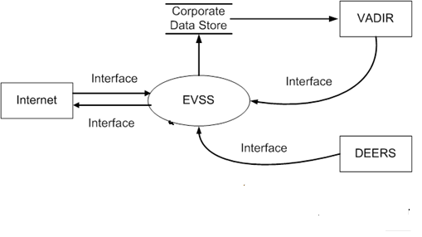

Figure : EVSSP2 Data Sharing Context Diagram

### High Level Application Design

The EVSSP2 primarily utilizes four types of application design to integrate with partners. They are as follows:

* WSRP
* HTML iFrame
* A custom-built portlet with new integration
* A custom-built portlet on an existing integration configuration

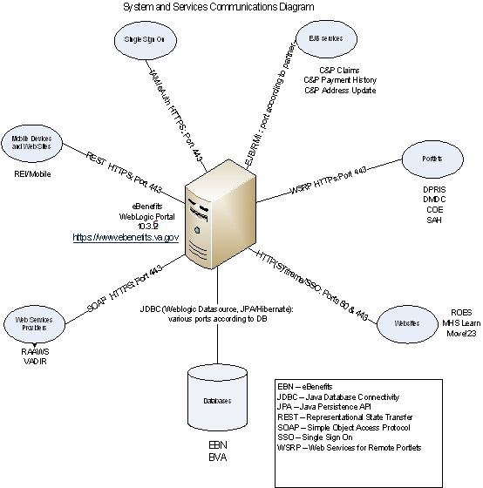

Figure : EVSSP2 High Level Integration Design

Table : EVSS High Level Application Design

| Name | ID | Description |
| --- | --- | --- |
| C&P Claims | S1 | Provides Veteran claims status information on their compensation & pension claims. |
| C&P Payment History | S2 | Provides Veteran payment history information for compensation & pension claims. |
| DPRIS | S3 | Provides Veteran information for Defense Personnel Reporting and Information System. |
| COE | S4 | Allows Veterans to view their certificates of eligibility. |
| SAH | S5 | Allows Veterans to apply for a specially-adapted housing grant. |
| **Internal Data Stores** | | |
| VADIR | 3 | The VA/DoD Identity Directory |
| BVA | 4 | Board of Veterans Appeals |

The design for forms platform uses an architectural approach for non-tier Web services that relies on a mesh of software services, including presentation, application, security, Enterprise service, and data service layers. The presentation layer consists of HTML forms that present to and accept input from users (from within the browsers on their desktops).

The overall design leverages much of the EVSSP2 design, which employs:

* A presentation layer comprised of thin client HTML forms on common browsers.
* An application layer implementation using Oracle’s WebLogic Enterprise JavaBeans (EJB) container.
* An Enterprise service layer comprised of VBA services (such as business process and workflow support, and data retrieval and update).

Figure 8 provides a high level overview of the application structural design.

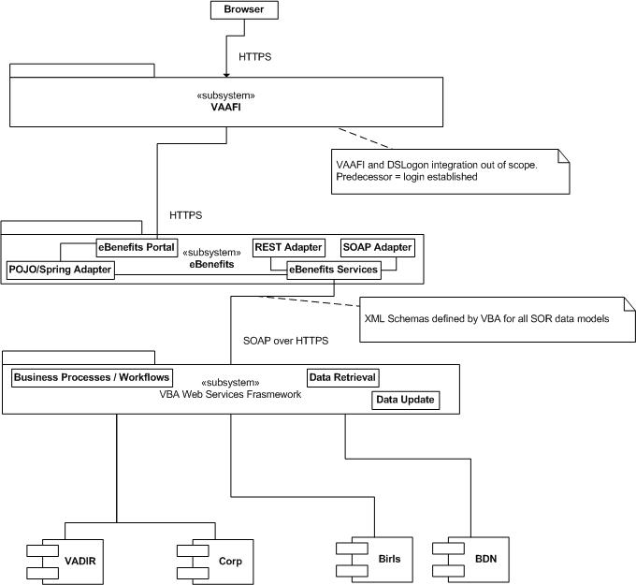

Figure High Level Application Structural Design

Increment 1 serves credentialed users with Level 2 DS Logons only. VA administrative users access other systems, including the St. Paul Rules-BPS and VETSNET claims processing.[6]

Table 10 lists the software product and version information used within the entire technology stack..

Table : Software Product Descriptions

| Software Class | Software Product | Version |
| --- | --- | --- |
| Web Server | Apache HTTP | 2.4 |
| Application Server | WebLogic Server | 12.1.3 |
| Relational Database Management System (RDBMS) | Oracle Database | 11G R2 (11.2.x) |
| Performance monitoring and profiling | CA Technologies IntroScope APM | CA Application Performance Management 9.1 (9.x) |
| Log viewing and alerting | XpoLog center | Version 5.0  (build 9.5.3.0) |
| Content Management | Alfresco Enterprise | 5.1.1 |
| Web Page Development | FreeMarker | 2.3.20 |
| Configuration Management | Clear Case | 8.0 |
| Source Code Management | Rational Team Concert | v6.0.1 iFix004 |
| Framework | Liferay | 6.2 CE GA6 (6.2.5) |
| Development Environment | JAVA EE | 1.8.x |
| Development Environment | Eclipse (dev only) | Eclipse Classic 4.5 & 4.6 |
| Virtual Environment Management (VM) | VM Ware  VCenter Server | vCenter 5.5 |
| RHEL OS | Red Hat RHEL | 7 (RHEL 5 for DB Only) |
| WSS Security | CA SiteMinder | 12.52 |

### Application Locations

Table 11 specifies the locations at which the application components will be hosted.

Table : Application Locations

|  |  |  |  |
| --- | --- | --- | --- |
| Application Component | Description | Location at Which Component is Run | Type |
| EBN | Web Portal | AITC |  |

Table 12 specifies the locations where the software components for forms platform are hosted. Hosting platforms include servers and network processing assets.

Table : Application Locations

| Application Component | Description | Location Where Component is Run | Type |
| --- | --- | --- | --- |
| Apache Web Server | Web Server | AITC | Present content without logic |
| Alfresco | Web Content Management System used to generate wizards and promote logic | AITC | Source control used to store and promote logic between regions |
| Oracle WebLogic | Application Server /  Java 8 | AITC | Java programming language support and runtime platform |
| Oracle Database Management System (DBMS) | Database | AITC | Data Store |
| Proxy | Proxy Gateways | AITC | Authentication Proxy |

### Application Users

The EVSSP2 system is utilized by Veterans, service members, and their families and is managed by system administrators at the AITC.

Table : User Groups

|  |  |  |
| --- | --- | --- |
| Application Component | Location | User |
| EBN system | AITC | System Administrators |
| EVSSP2 | Access via www.ebenefits.va.gov | Veterans, service members, family members |

Users of the forms platform are categorized depending on their level of access. Table 14 lists the terms used in the level of access definitions.

Table : Terms Used in Level of Access Definitions

| Term | Definition |
| --- | --- |
| DMDC | Defense Manpower Data Center |
| DEERS | Defense Enrollment Eligibility Reporting System |
| CSP | Credential Service Provider |
| DS Logon | Defense of Defense (DoD) Self-Service Logon |

Table 15 defines all of the existing levels of access.

Table : Existing Levels of Access

| User | Level of Access |
| --- | --- |
| Anonymous | No Authentication. |
| Level 1 DMDC | Authenticated at DMDC with no in-person proofing; ID exists in DEERS. |
| Level 2 DMDC | Authenticated at DMDC with in-person or remote proofing; ID exists in DEERS. |
| Level 3 DMDC | Authenticated at DMDC in-person or remote; ID exists in DEERS; used a second factor (personal identification number [PIN] Short Messaged Service [SMSed] to cell phone). |
| Level 1 VA CSP | Authenticated at VA CSP with no in-person proofing; ID most likely not in DEERS (may later be added to DEERS if adjudicated as Veteran). |
| Level 2 VA CSP | Authenticated at VA CSP with in-person or remote proofing; ID most likely not in DEERS (may later be added to DEERS if adjudicated as a Veteran’s beneficiary). |

While the long-term business vision for the forms platform is to provide service to all of the user groups above, the first two increments of the forms platform are limited in scope to select user groups. Table 16 specifies the users for whom the forms platform will be available to after the first two project increments for the forms platform.

Table : Application Users

| User | Location | Application Component |
| --- | --- | --- |
| Level 2 DMDC credentialed Veteran (Increment 1) | World Wide Web (WWW) | FORMS PLATFORM |
| Level 1 VA CSP and Level 2 DMDC credentialed user (Increment 2) | WWW | FORMS PLATFORM |

## Conceptual Data Design

Data access services represent data retrieval needs abstracted through a service. These can be exposed intra-application or inter-application based on reuse potential and security requirements.

The design considerations are employed as shown in Table 17 through Table 20.

Table : Conceptual Data Design Service Layers

| Place data access concerns behind the intra and inter application service layers. | |
| --- | --- |
| Supporting Factors | * Decouples data access from presentation tier. * Allows flexible data reuse. * Relies upon existing service frameworks and communication mechanisms to reduce redundant code. |
| Detracting Factors | Some overhead inherited by additional layers. |

Table : Conceptual Data Design – Object Mapping

| Use Hibernate w/ JPA for object relational mapping. | |
| --- | --- |
| Supporting Factors | * Standard, enterprise proven technology. * Allows application/DB decoupling. * Supports integration with Spring container. * JPA allows decoupling from Hibernate, as code can be moved to any JPA-compliant ORM provider. * Framework for transactional data access. * Resolves most SQL needs for developers. * Highly tunable. * Supports container managed JDBC pools for DB access. |
| Detracting Factors | * Does not solve batch processing needs efficiently. * ORM comes with added complexity. |

Table : Data Design – Service Layer

| Use Spring Aspect Oriented Programming techniques to demarcate transaction boundaries in the service layer. | |
| --- | --- |
| Supporting Factors | * Handles transaction concerns for service developers at the framework level. * Efficient way to enforce transactions by interface. * Removes redundancy. * Participates with existing transactions such as an Enterprise JavaBeans (EJB) or client initiated transaction. |
| Detracting Factors | * AOP can seem mysterious to new or junior developers. This, along with other complicated or less common techniques, should be worked into training/ramp-up material to aid resource education. * Limited transaction participation strategies |

Table : Data Design – Stored Procedures

| Use DBMS stored procedures to provide record level auditing where required. | |
| --- | --- |
| Supporting Factors | * Faster than using the application tier to perform record auditing. * The most fail-safe way to track DB record changes. * Frameworks can be written so audit stored procedures are reused by new tables. * Removes audit logic from persistence code, reducing complexity. |
| Detracting Factors | * Stored procedures require special skills that differ from the other development resources. * Stored procedures must be maintained with the DB schema and can be troublesome to manage. |

## Project Conceptual Data Model

The EVSS conceptual data model is shown below. The model indicates a typical construction of entities, relations between entities in the same subject area, and across subject areas.

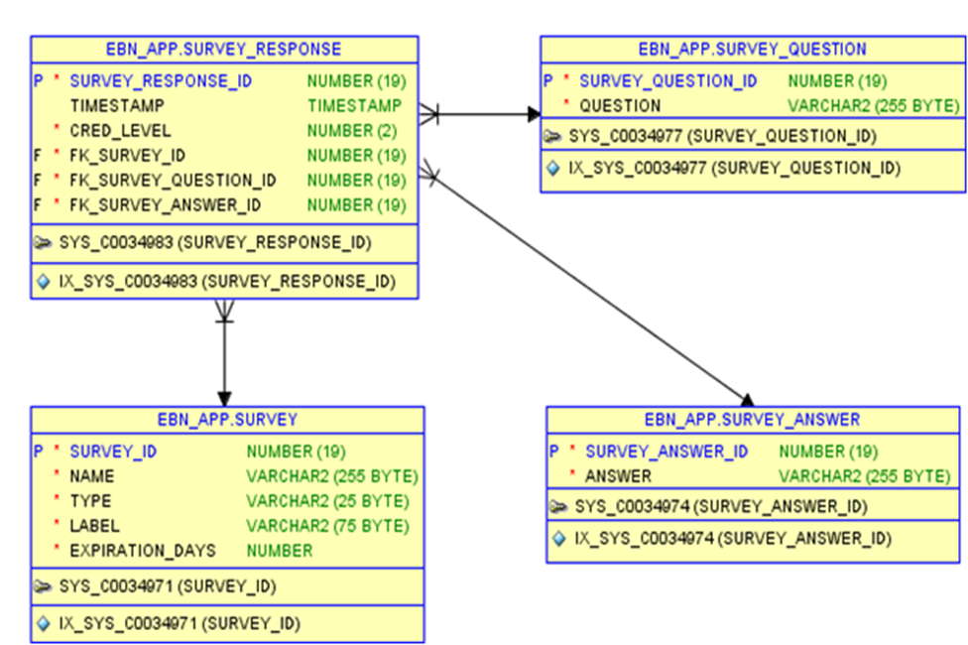

Figure : EVSSP2 Conceptual Data Model

### Database Information

Table 21 identifies all databases that will be created, replaced, interfaced with, or whose structure will be modified (i.e., add or delete tables or add or delete columns to a table) as part of this effort.

Table : Data Inventory

| Database Name | Description | Type | Steward |
| --- | --- | --- | --- |
| Corporate DB | Veteran Profile Information used for eligibility | Interface | VETSNET |
| Electronic Claim Tables  (Corporate DB) | Claims submitted online from the Veteran | Interface | VBA |
| DEERS | Verification of service to allow for benefits | Interface | DMDC |
| VADIR | VA/DoD Identity Repository | Interface | IAM |
| VACOLS | Veterans Appeals’ Control and Locator System | Interface | BVA |
| MVI | Master Veteran Index | Interface | VAP/CPP |

Table 22 identifies all databases that interface with the forms platform as part of this effort.

Table : Database Inventory

| Database Name | Description | Type | Steward |
| --- | --- | --- | --- |
| BIRLS | Beneficiary Identification and Record Locator Subsystem | TBD | TBD |
| CorpDB | VA Corporate Database | TBD | TBD |
| BDN | Benefits Delivery Network | TBD | TBD |

## Conceptual Physical Architecture Design

The conceptual physical architecture is shown in Figures 10 and 11.

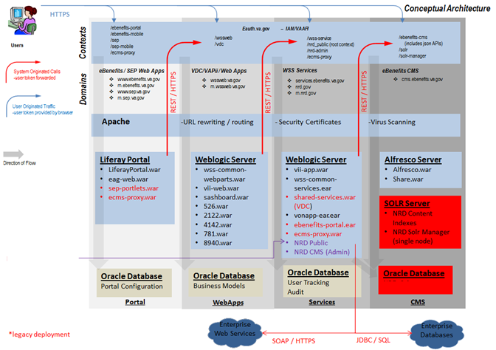

Figure : Conceptual Physical Architecture Design

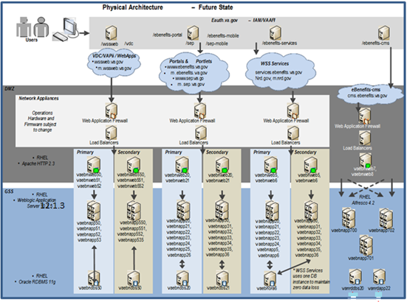

Figure : EVSSP2 Production Architecture Design

The forms platform allocates application and data services to system nodes, further decomposing these nodes by type of platform, interface category, and local storage requirement (see the following tables for initial estimates, which are updated as more detailed information becomes available). Table 23 includes the information and estimates for the server class, hosts, central processing unit (CPU), memory, and disk requirements.[7]

Table : Unique Technology of the Infrastructure Design

| Server Class | Hosts | CPU | Memory | Disk |
| --- | --- | --- | --- | --- |
| Web Server | 2 | 4 | 8 Gigabytes (GB) | 50 GB |
| Application Server | 2 | 8 | 16 GB | 50 GB |
| Database Server | 1 | 8 | 8 GB | 100 GB |

Table 24 includes information about the software classes and requirements for Internet Protocol (IP) addresses, along with descriptions of both the Web Server and IP addresses for the FORMS PLATFORM II Project.

Table : Unique Technology of the Infrastructure Design Description

| Software Class | Explanation |
| --- | --- |
| Web Server | Web servers are requested to segregate inbound user traffic from communications with the WebLogic cluster. Additionally, an administrative interface is requested to isolate backups and system administration (SA) access. |
| Application Server | Application servers are requested to segregate inbound requests from the Web servers and cluster management traffic. Additionally, an administrative interface is requested to isolate backups and SA access. |
| Database Server | Database servers are requested to isolate inbound MS Structured Query Language / Java Database Connectivity (SQL/JDBC) requests from administrative access and operations. |

### System Criticality and High Availability

EVSSP2 shall be accessible and functioning except during maintenance periods. System maintenance activities shall be conducted after normal VA business hours.

The application availability will be deferred to the AITC team. As a standard practice, the EVSSP2 production and test servers will be deployed to a WebLogic cluster with two managed servers each running on a different machine in a classic load-balance and fail-over topology.

The recommended forms platform architecture has been divided into layers, network regions, and server clusters. This layout provides horizontal scaling through the addition of new servers to the existing clusters. Vertical scaling depends on the hardware devices chosen by VA operations. A server cluster may be scaled by the addition of new servers that match the existing hardware and software standards if it is determined that existing servers are not performing adequately. Vertical scaling can be achieved due to the virtualization of resources. Existing servers can be allocated additional resources. Pilot performance testing will provide the data needed to produce a scaling model. This model will outline the additional capacity gained by adding hardware resources.

Although out of scope for this document, data center resources that must be addressed include:

* Wiring
* Protocols
* Routers
* Bridges
* Firewalls
* Load balancers

### Special Technology

No special technology has been identified at this time.

### Technology Locations

Table 25 describes the current technology configurations.

Table : Technology Location

| Technology Component  Production 1 | Location |
| --- | --- |
| Workstations | **Universal** |
| Special Hardware | **None** |
| Interface Processors | **AITC** |
| Legacy Mainframe | **Hines (CDB), AITC others** |
| Legacy Application Server | **Universal Locations** |
| Legacy Databases | **None** |
| Other | **TBD** |

### Conceptual Infrastructure Diagram

The existing data centers and network support devices must be audited to ensure they are adequately sized for the new traffic. These network devices are primarily covered by current assets:

* Domain Name System (DNS)
* Data Centers
* Wiring
* Protocols
* Routers
* Bridges
* Firewalls
* Load Balancers

#### System Location of Environments and External Interfaces

This information may be found in the EVSSP2 Product Operations Manual located in the VA Rational Team Server Suite at https://clm.rational.oit.va.gov/ccm/web/projects/EVSS%20(CM).

#### Conceptual Production String Diagram

Figure 12 shows the sequence of interactions between the components in the execution of the “Add Dependent” feature of the forms platform. The user employs the browser that contains the HTML interface and clicks **Add Dependent**. After verifying the user’s identity by VAAFI, EBN provides a form wizard with an embedded PDF that is pre-populated with the user’s data through the VBA Service Framework.

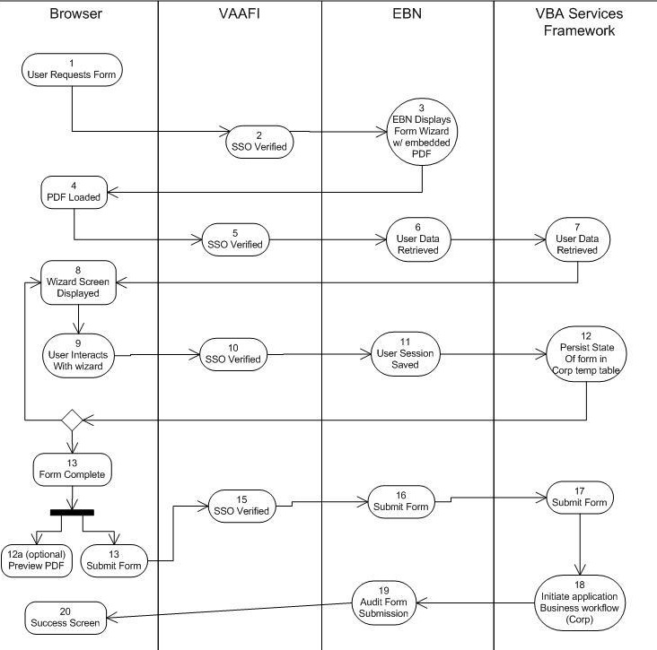

Figure : Forms Platform Interaction Design for Add Dependent Process[8]

### Conceptual Infrastructure Design

The platform allocates application and data services to system nodes, further decomposing these nodes by type of platform, interface category, and local storage requirement (see the following tables for initial estimates, which are updated as more detailed information becomes available). Table 26 includes the information and estimates for the server class, hosts, central processing unit (CPU), memory, and disk requirements.[9]

Table : Unique Technology of the Infrastructure Design

| Server Class | CPU | Memory | Disk |
| --- | --- | --- | --- |
| Web Server | 4 | 8 Gigabytes (GB) | 50 GB |
| Application Server (includes WebLogic) | 8 | 16 GB | 50 GB |
| Database Server | 8 | 8 GB | 100 GB |

The table includes information about the software classes and requirements for Internet Protocol (IP) addresses, along with descriptions of both the Web Server and IP addresses for the FORMS PLATFORM II Project.

### Special Technology

No special technology has been identified at this time.

### Technology Locations

Technology locations are described in the portal operations manual and may be found at URL https://clm.rational.oit.va.gov/ccm/web/projects/EVSS%20(CM).

# System Architecture

This section provides a high level architectural view of EVSSP2. The main goal is to provide a foundational view of EVSSP2 (where it fits and how it interacts with other VA Enterprise Applications).

## Hardware Architecture

The EVSSP2 network makes use of existing network standards and topology of the AITC data centers. The existing data centers and network support devices must be audited to ensure they are adequately sized for the new traffic. These network devices are primarily be covered by current assets:

* DNS
* Data Centers
* Wiring
* Protocols
* Routers
* Bridges
* Firewalls
* Load balancers

## Software Architecture

Figure 13 depicts the detailed software architecture of the EVSSP2 system. For more details, see the Software Design section of Detailed Design.

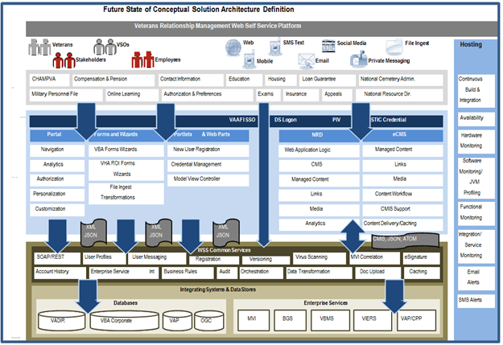

Figure : Conceptual Architecture

## Communications Architecture

All Authenticated SSL (HTTPS) traffic is routed via a secure SSL tunnel (Port 444) to assert their identity to the receiving web application. The web application then picks up the identity from SSL headers and propagates the authentication. All unauthenticated SSL (HTTPS) traffic is routed via a secure SSL Tunnel (Port 443) to the receiving web application server.

## Service Oriented Architecture

EVSSP2 was designed following guidance from ASD, in compliance with TRM. The EVSSP2 design is based on principles described in the Enterprise Architecture Framework following VA ETA principles, which include service oriented modeling, architecture, orchestration and platform delivered as a service (PaaS). Where possible EVSSP2 produces consumable WSCR and REST and API for other portals in the VA to connect. EVSSP2 has dependencies on several partners and is a major consumer of services offered by partners.

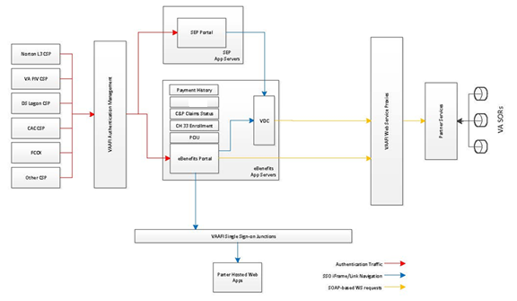

Figure : Service Oriented Architecture

In EVSSP2 and adhering to VA; SOA is a style of architecting EVSSP2 applications in such a way that they are composed of discrete software agents that have simple, well defined interfaces and are orchestrated through a loose coupling to perform a required function. As such, there are 2 roles in SOA- a service provider and a service consumer. A software agent may play both roles. SOA is not an entirely new concept – however, this article mainly focuses on SOA as implemented with web services.

In EVSSP2, we follow the following principles:

* Divide EVSSP2 code into reusable modules.
* Encapsulate in a module any design decision that is likely to change.
* Design your modules in such a way that they can be combined in different useful way
* Orchestrate and expose services when possible
* Manage diligently Web Service Change Requests WSCR
* Sustain WSDL, JSON and REST connections

In EVSSP2 SOA is achieve when modules communicate by sending messages to each other over the network, rather than by more traditional programming-language mechanisms like procedure calls. In particular, in EVSSP2enterprise application service-oriented architecture the parts generally don't share mutable state (global variables in a traditional program). Or if they do share state, that state is carefully locked up in a database which is itself an agent and which can easily manage multiple concurrent clients.

## Enterprise Architecture

EVSSP2 is designed based on VA Enterprise Architecture Framework and closely following FEAF, Zachman and OneVA. EVSSP2 is modeled based on GAO-10-846G.

Specifically EVSSP2 follows the GAO CIO council, <http://www.gao.gov/assets/590/588407.pdf>

EVSS is also built on OneVA and TRM principles described, <http://www.ea.oit.va.gov/>

EVSS is in full compliance with ETA

<http://www.ea.oit.va.gov/EAOIT/docs/April_2014_Release_Docs/OneVA_EA_ETA_Compliance_v3_03312014.pdf>

The EVSS design:

* Ensure interoperability of solutions
* Transition IT capabilities to the technology environment envisioned in the VA IT Roadmap

EVSS Application developers ensure that solutions developed are in alignment with enterprise-wide technical guidance and to help prepare for milestone review processes. All VA solutions and investments are in compliance comply with the business and technical layers of the OneVA EA. It should be noted that the ETA represents the technical layer of OneVA EA allowing for EVSSP2 compliance.

EVSSP2 is built in many tiers, portal, web, and services, including clusters to aid the orchestration of transactions and calls.

Figure 15 represents a high level view of the tiers in which the application is built, including components at different cluster layers.

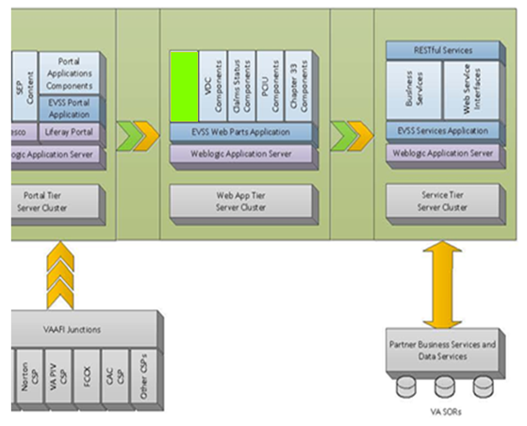

Figure : High Level Application Tiers

## Development Platform

Table 27 provides a detailed listing of the various EVSSP2 environments and the software and development tools used to build and support the environments. We are also using Red Hat v6 and also SiteMinder 12.5.2.

Table : EVSSP2 Development Platform

| Environment | Software/Tool | Vendor/Version |
| --- | --- | --- |
| Development | Sun Java SDK | Sun Java Development Kit (JDK) 1.8 |
|  | Development – Integrated Development Environment (IDE) | Eclipse Classic 4.5 & 4.6 |
|  | Database | Oracle 11g R2 |
|  | Source Code Repository | Rational RTC |
| QA / Partner Integration Testing Region(PINT) | Portal Framework | LifeRay Portal 6.2 CE GA6 (6.2.5) |
|  | Application Server | Oracle WebLogic Server 12.1.3 |
|  | Server operating system (OS) | Red Hat RHEL 7 (RHEL 5 for DB Only) |
|  | DBMS database | Oracle 11GR2 |
|  | Front-end Web Servers | Apache HTTP Server 2.4 |
| Pre-Prod / Staging | Portal Framework | LifeRay Portal 6.2 CE GA6 (6.2.5) |
|  | Application Server | Oracle WebLogic – 12.1.3 |
|  | Server OS | Red Hat RHEL 7 (RHEL 5 for DB Only) |
|  | DBMS | Oracle 11g R2 |
|  | Front-end Web Servers | Apache HTTP Server 2.4 |

# Data Design

The actual EVSSP2 Data Model is based upon an Oracle database and Apache and WebLogic server clusters communicating with various VA and DoD systems. Refer to the “Data Architecture and Matrix” documents for further information.

## Database Management System Files

This section does not apply as no new database interactions are defined for the forms platform.

## Non-Database Management System Files

This section does not apply as no new database interactions are defined for the forms platform.

## Local data structures

EVSSP2 does not contain native data storage for system of record information as it acts as a front-end portal which retrieves data from background data stores.

At this time EVSSP2 stores only analytics, user portal profile and preferences, and audit trail information; please refer to the “Data Architecture Matrix” for information including ERDs.

# Detailed Design

The purpose of this section is to provide

* A detailed description of the hardware platform where EVSSP2 will be installed
* A detailed description of the EVSSP2 software design (framework, API, etc.)

**Note:** Every design item should map back to the Functional Requirements Document. These should be captured in the RTM.

## Communications Design Concept

All Secure Sockets Layer (SSL) Hypertext Transfer Protocol Secure (HTTPS) traffic is routed to the IAM proxy via Port 443. IAM then redirects the traffic to the credential provider (DMDC) via a secure SSL tunnel (Port 444) and uses Security Assertion Markup Language (SAML) to perform the authentication process.

IAM will insert SAML headers into requests of users that are authenticated (Level 2 DS Logon) to assert their identities to the receiving web application. The web application then picks up the identity from SAML headers and propagates the authentication.

## Hardware Design

Because the hardware and software platforms are common between EBN, VONAPP, VONAPP II, VDC, and SEP the hardware considerations consist mostly of measuring and planning for the impact of the additional load caused by increased users on the system. The projected environment may be adequately sized to support the increased EVSSP2 traffic. In determining recommendations for region sizing, the following approaches and considerations should be involved:

* Consider recommendations in the WebLogic 10 Capacity Planning Guide at <http://e-docs.bea.com/wls/docs100/perform/appc_capplan.html>.
* Analyze traffic volume information provided for existing VA Portals.
* Perform performance tests against EVSSP2 Portal to create capacity metrics.
* Apply capacity metrics to expected traffic volumes to establish baseline hardware requirements.
* Allow for future growth and significant margin of error.
* Allow for 100% failover.

The current region sizing is based on the knowledge acquired by running the EVSSP2 Application.



Figure Physical Architecture Design

### Hardware Scaling

The recommended architecture is organized by layers, network regions, and server clusters. This layout provides horizontal scaling through the addition of new servers to the existing clusters. Vertical scaling is dependent on the hardware devices chosen by operations. If determined that the existing servers are not adequate, a server cluster may be scaled by the addition of new servers matching the existing hardware and software standards. Vertical scaling can be achieved by the virtualization of resources. Existing servers can be allocated as additional resources.

Network scaling may be required if traffic grows extensively over time. Although out of scope for this document, the following data center resources must be addressed:

* Wiring
* Protocols
* Routers
* Bridges
* Firewalls
* Load Balancers

### Hardware Environment Configurations

The production (PROD) region is the live site for EVSSP2 that end users access on a day-to-day basis.

The Pre-production region is a mirror of the production region. It is used for performance testing and serves as the staging region

The integration testing environment mimics the physical layout of production. This region mimics the layers used in production, but not the capacity. This environment is only visible to internal VA integration partners.

Partner Integration Testing (PINT) environment is an integration testing environment that mimics the physical layout of production. This region mimics the layers and the capacity of the production environment. However, this environment is available to both internal and external integration partners.

The development integration (INT) environment mimics the physical layout of production. This region mimics the layers, but not capacity

Specific hardware configuration details for each of these hardware configurations is maintain in the Production Operations Manual (POM) and may be viewed at URL <https://clm.rational.oit.va.gov/ccm/web/projects/EVSS%20(CM)>.

## Software Detailed Design

The EVSSP2 is a JAVA enterprise portal comprised of multiple applications. Java communicates over to Oracle as a backend and we use Alfresco and Liferay as our frameworks for development. All design is based on HTML5 using FreeMarker 2.3.x.

The target vision for the EVSSP2 software platform is currently intended to consist of three logical tiers, each made up of an independent cluster of WebLogic Application Servers – a Portal tier, a Web App tier, and a Service tier. Additional servers hosting Apache, Oracle, Solr, and Alfresco support each cluster. For brevity, those components will be omitted from further discussion of the EVSSP2 Platform as the focus here is on the logical landscape of the new platform and not on the supporting infrastructure. The three main logical tiers are described as follows.

**The EVSS Portal Tier**

The Portal tier is intended to host the consolidated EVSSP2 Portal application stack. Once the core EBN features are migrated to Liferay Portal and the SEP codebase, the codebase should be referred to as EVSSP2 Portal rather than SEP Portal. EBN Portal and SEP Portal will essentially be segmented content.

The EVSSP2 Portal Tier serves up all static information content and resources, it will manage authentication of users, and it will determine user groups and roles by evaluating the session data provided by Identity and Access Management.

Veterans and Active Duty Service members authenticated via a DMDC CSP will be served an EBN experience, and VSOs, Attorneys and Agents, Employers, and Providers will be served an SEP experience. Further segmentation and content customization can be added to enhance the user experience for any of the supported user bases.

**The EVSSP2 Web App Tier**

The Web App tier is intended for EVSSP2-hosted “features” that can be navigated to from the Portal. iFrame access from the Portal to the Web Apps will ensure a seamless user experience. The Web Apps hosted on this tier can be individually extended and maintained with a significantly reduced regression boundary once they are no longer integrated in the legacy eBenefits codebase. This will be possible because front-end changes made to a specific feature will not rebuilding all software artifacts. Portal content, partner iFrames and SSO links, and shared services will lie outside the regression boundary. Additionally, these feature can be made available to the users of any of the portals, as well as other Web Apps.

**The EVSSP2 Service Tier**

The Service tier is intended to host any reusable business services or commands that are needed by more than one application. Some examples of business commands are as follows:

* Address validation services that are needed by many applications
* A web service client that sources data from a partner system
* A document conversion tool that converts various document types to PDF
* A user profile service that collects and provides identifying information on the currently logged in user.

Without these reusable services, each codebase that requires the functionality would need to either create and maintain their own version of the functionality or rely on shared library files that could potentially fall out of date and require continued unexpected maintenance.

The service tier also provides a single maintenance point where virtually all partner services can be evaluated for performance. Through horizontal and vertical scaling and through localized data caching and service throttling, we can work toward a goal of high throughput and solid performance of all partner service integration points.

Finally, the vision for the service tier is that it will maintain the enterprise domain model that is utilized by all applications in EVSSP2 ecosystem. Data consistency can be better managed if all transformation, validation, and filtering occurs in a single place.

The EVSSP2 primarily utilizes four types of application design to integrate with partners. They are as follows:

* WSRP
* HTML iFrame
* A custom-built portlet with new integration
* A custom-built portlet on an existing integration configuration

The design for EVSSP2forms platform uses an architectural approach for non-tier Web services that relies on a mesh of software services, including presentation, application, security, Enterprise service, and data service layers. The presentation layer consists of HTML forms that present to and accept input from users (from within the browsers on their desktops).

The overall design leverages much of the EVSSP2 design, which employs:

* A presentation layer comprised of thin client HTML forms on common browsers.
* An application layer implementation using Apache’s Tomcat and Oracle’s WebLogic Enterprise JavaBeans (EJB) container.
* An Enterprise Service layer comprised of VBA services (such as business process and workflow support and data retrieval and update).

## Service Oriented Detailed Design

Section 4.4 explained the high level SOA in adherence with VA ETA framework. This section explains the details of protocols and communications.

EVSSP2 follows the VA SOA Technical Framework v0.3.1.

<http://www.ea.oit.va.gov/EAOIT/docs/VA_SOA_Technical_Framework_v_0-3-11.pdf>

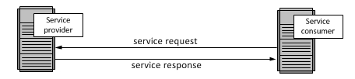

**Figure 17: Service Oriented Detailed Design**

EVSSP2 is both provider and consumer of goods and services. We have built our services to be reliable and scalable and to adhere to both SOA policies and SLA obligations.

EVSSP2 has web services that exchange information in XML as described in the communication detail design section from below. It also uses ESB for common orchestration. For EVSSP2 we can make the following distinctions, EVSSP2 SOA versus OOA/OOD Similarities: Encapsulation, Abstraction and Defined Interfaces o Differences: EVSSP2 SOA is loosely coupled with no class hierarchy or inheritance, Low-level abstractions - class level versus business service.

EVSSP2 is built as an enterprise portal comprising multiple applications over n-tiers, presentation, web-servers, business-layer, web-app servers, and backend database RAN servers all work together to complete requests and transactions.

In EVSS Services are software components that have published contracts/interfaces; these contracts are platform-, language-, and operating-system-independent. XML and the Simple Object Access Protocol (SOAP) are the enabling technologies for SOA, since they're platform-independent standards. Consumers can dynamically discover services. Services are interoperable.

In EVSS Using SOA offers several key advantages. You can:

Adapt EVSSP2 applications to changing technologies.

Easily integrate EVSSP2 applications with other systems.

Leverage existing EVSSP2 investments in legacy applications.

Quickly and easily create a EVSSP2 business process from existing services.

# EVSSP2 AITC Hardware Inventory

The detailed EVSSP2 AITC hardware inventory is recorded and maintained in the EVSSP2 Production Operations Manual located in the EVSS Rational Team Server suite at URL https://clm.rational.oit.va.gov/ccm/web/projects/EVSS%20(CM)

# Platform Scaling and Tuning

Legacy EBN and SEP originally each resided on a singular application tier. A single cluster of 14 nodes provided scaling capability. In the case of EBN, Anonymous, Level 1 and Level 2 traffic was all served from the same tier; that tier was also responsible for all external back-end integration traffic, such as web service and JDBC connections to partner systems.

Under the consolidated platform model, with the Portal, Web Apps, and Services components each residing on a different WebLogic Application Server cluster, the tiers can be individually tuned and scaled.

**The 3-tier Approach in Action**

In a typical example scenario involving all three clustered tiers, a user would navigate to the eBenefits.va.gov domain and potentially browse the static content on the website. Should the user choose to navigate to the Compensation and Pension Claims Status feature of EBN, they will need to authenticate using the externally integrated DS Logon CSP provided by DMDC. This involves navigation to an externally-hosted login page hosted by DMDC. When the user authenticates, the SAML response provided by DMDC is intercepted by VAAFI and transformed into session headers that are consumed by the Portal. At that point, with the identity of the user known, the EVSSP2portal loads the EVSSP2 profile for the user and creates an active secure browsing session. The Portal may utilize the service tier to prefetch data from VA SoRs in order to complete the composite user profile.

Once the user has logged into the EVSSP2 Portal, they can navigate to the Claims Status feature that they originally intended to visit prior to having their identity authenticated. The VAAFI login session and VAAFI traits provided to the system at login allows the user to access the feature and see only their data. The Claims Status feature is a web app hosted on the Web App tier, and it is accessible to the user via an iFrame integration that leverages the SSO capabilities provided by VAAFI. The traffic, any processing, content assembly, and delivery of the web pages for the feature is now handled by the Web App tier.

In order for the Claims Status feature to work properly, the user’s data needs to be delivered to the web browser in the form of dynamic content. The web browser makes a resource request to pull the needed data. The request initiates a RESTful web service call to the EVSSP2 Service tier which activates a business service responsible for serving the required data. The business service first checks the Service Tier cache to determine if the data already exists for that user, and, if the cache data is not available, it initiates a SOAP-based web service call to a partner system, which pulls the data from the appropriate VA System of Record. The response is parsed, rules applied, data validated and formatted, and the result is passed back to the browser in the format of the resource originally requested. All of this activity is handled exclusively by the EVSSP2 Service tier.

**Individually Tunable Clustered Tiers**

In the above example, we can clearly see that each tier performs very specific functions. For a given Anonymous user experiencing one of the EVSSP2 Portals, there exists the potential that the Web App and Service tiers may never be engaged. For a Level 2 authenticated user, it is likely that the browsing experience will involve all three tiers. The three-tier approach allows each of the clusters to be individually tuned based on current traffic patterns and overall load on the system.

By default, each tier consists of a 14-node cluster. Vertical scaling can be achieved by increasing or decreasing the amount of available CPU, memory and disk on each tier. Horizontal scaling can be achieved, initially, by migrating unneeded server capacity from one tier to another tier that may be supporting more traffic. Additionally, any tier can be further scaled horizontally by requisitioning additional servers for that tier’s cluster. Standard monitoring tools will monitor the needed capacity of each of the platform tiers providing the EVSSP2 O&M team the metrics needed to make the scaling decisions for each tier.

## External Interface Design

The purpose of this section is to describe the interfaces between EVSSP2 and other VA and DoD external systems.

## Interface Architecture

EVSSP2 interface architecture is dependent on the structure of the integration partner and the type of portlet they wish to use with EVSSP2. The following sections outline the interface types and detail the communication between systems.

## Interface Detailed Design

The VADIR/EVSSP2 service interface is a remote system-to-system web service call. The EVSSP2 end-user initiates the remote call by navigating to sites containing fields within the EVSSP2 web site that seek to pre-fill the user’s personal information—information that is housed in the VADIR database.

The VADIR/EVSSP2 early communication service interface is a JDBC call to a staging table in VADIR. The EVSSP2 backend service initiates the remote call to the VADIR service for seeking information about event ID, email, change Status Date, and Electronic Data Interchange Personal Identifier (EDIPI) from the VADIR database.

The web services call will use SOAP protected by Transport Layer Security (TLS) between the servers after mutual authentication. Data transferred under this agreement will include the Veteran’s personal information, personal contact information, and periods of military service.

EVSSP2 will provide VADIR with the EDIPI associated with the Veteran using the site. The VADIR service will return the requested data stored in its repository.

### VADIR System Interfaces

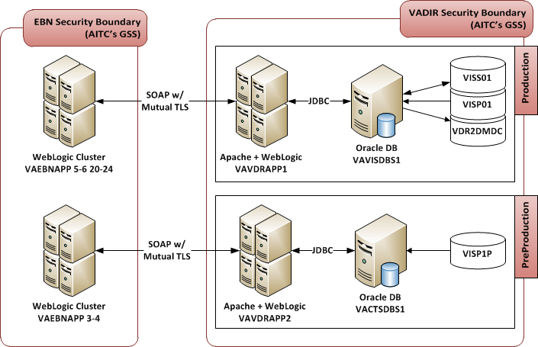

Figure : VADIR System Interfaces and Data Flow

Table 28 outlines server/certificate identification environments.

Table : Environment Server/Certification Identification

| Server/Certificate Identification | |
| --- | --- |
| VADIR Production | VA Internal Root CA/VA Internal Subordinate CA  VAVDRAPP1.AAC.VA.GOV |
| VADIR Preproduction | VA Internal Root CA/VA Internal Subordinate CA  VAVDRAPP2.AAC.VA.GOV |
| EVSSP2 Production* | Cybertrust Root CA/Cybertrust Root CA 1  www.EVSSP2.va.gov |
| EVSSP2 Preproduction* | VA Internal Root CA/VA Internal Subordinate CA 1  EVSSP2-preprod.aac.va.gov |
| *\*EVSSP2 is requesting new certificates to distinguish servers in the GSS from servers in the DMZ. This document will be updated accordingly once they have been issued.* | |

### Board of Veterans Appeals Interface Definition

The Board of Veterans Appeals (BVA)/EVSSP2 service interface is a remote system-to-system web service call. The EVSSP2 end-user initiates the remote call by navigating to a portlet on the EVSSP2 website which allows the user to view the status of open appeals, historical appeals, and details of appeals with the BVA—information that is housed in the BVA’s database, the Veterans Appeals’ Control and Locator System (VACOLS).

The web services call utilizes JDBC protected by TLS between the servers after mutual authentication. Data transferred under this agreement includes the Veteran’s open appeals, historical appeals, a timeline of appeals, appeals detail, and appeal correspondence.

EVSSP2 provides the BVA with the SSN associated with the Veteran using the site. For appeals details, a claim ID number is provided by the Veteran to facilitate the JDBC remote call. The VACOLS database returns the requested data stored in its repository.

### BVA System Interfaces

The triggering event for the EVSSP2/BVA interface entails a Level 2 authenticated Veteran requesting information regarding his/her appeals through the BVA’s portlet on the EVSSP2 Web Portal.

This triggering event by the Veteran initiates a remote call for information that is housed in BVA’s VACOLS database. This remote call utilizes the DBC, protected by TLS between the servers after mutual authentication. EVSSP2 provides BVA with the SSN associated with the beneficiary in question. Database calls are specified to retrieve open and historical appeals data, appeals details, appeals correspondence, and a timeline of the Veteran’s appeals status.

### Employment Center Interface (EC)

EC (provided by any external partner), allows Veterans and employers to perform activities normally associated with searching for a job or matching job seekers with employers. Users will access EC from the EBN home page and will have access to the following job related functions:

1. Resume Builder
2. Military Skills Translator
3. Job Search

Users looking to create a resume or translate military skills and training to equivalent non-military positions would access these areas of EC. Users looking to search for jobs from employers that have committed to hiring Veterans would access the job search function. The EC job search function interfaces with the National Labor Exchange (NLX) through a standard API. Further information is provided in the NLX Interface Control Documentation.

### DMDC Interface Definition

The DMDC-EVSSP2 service interface is a remote system-to-system web service call. The EVSSP2 end-user initiates the remote call by signing on to EVSSP2 with his/her DS Logon account—information that is housed in DEERS and under the purview of VA’s IAM team.

The data transfer for this interface is accomplished by WSRP Version 1.0. WSRP is a standard way to display a remote portlet on a portal application. The EVSSP2 team prepares EVSSP2 to consume the remote portlet.

Data transferred under this agreement includes user’s full name, single sign on token, DoD electronic data identifier, credential level, email address, SSN, date of birth, and business information. Figure 19 portrays DMDC interfaces.



Figure : DMD Interfaces and Data Flow

### Forms Platform Interface Definition

This EVSSP2 interface is a standard HTTP integration with SSO enablement between EVSSP2 and the Forms Platform via VA’s IAM. The end-user initiates the interaction by selecting to access VA application forms through various links on the EVSSP2 site.

EVSSP2 provides information to the user by interfacing with the forms platform using an HTML Inline Frame (iFrame), protected by TLS between the servers after mutual authentication. There is navigational data exchanged between a user’s browser during SSO which is non-sensitive.

EVSSP2 provides the VA’s IAM with the EDIPI associated with the Veteran using the site. Upon Level 2+ user authentication, EVSSP2 interfaces with the Forms Platform using an HTML iFrame via the IAM proxy. This interface allows the user to complete his/her application on the forms platform website through the IFrame on the EVSSP2 Web page.

#### Forms Platform System Interfaces

The Forms Platform-MVI service interface is a remote system-to-system web services-based interface. The EVSSP2 end-user initiates remote calls by initiating or continuing an application in the Forms Platform portlet.

These SOAP/HL7 web services utilize MVI provided system authentication credentials and TLS between the servers after mutual authentication. Data transferred under this agreement include the Veteran’s PII along with their correlating IDs from BIRLS and VBA Corporate.

### Veterans Network (VETSNET) Interface Definition

The VETSNET/EVSSP2 service interface is a remote system-to-system web service call. The EVSSP2 end-user initiates the remote call by navigating to a portlet on the EVSSP2 website which allows the user to view the status of his/her C&P Claims, historical claims, and details of VETSNET claims —information that is housed in VETSNET’s database.

The web services call utilizes EJB protected by TLS between the servers after mutual authentication. Data transferred under this agreement includes the Veteran’s C&P claims.

EVSSP2 provides VETSNET with the SSN associated with the Veteran using the site. For C&P claim details, a claim ID number is provided by the Veteran to facilitate the EJB remote call. The VETSNET database returns the requested data stored in its repository.

#### VETSNET System Interfaces

Figure 20 displays the direct connection between EVSSP2 and the VETSNET EJB interface.

The triggering event for the EVSSP2/VETSNET interface entails a Level 2 authenticated Veteran requesting information regarding his/her C&P claims through the C&P Claims Status portlet on the EVSSP2 Web Portal.

This triggering event by the Veteran initiates a remote call for information that is housed in the VETSNET database. This remote call utilizes the EJB, protected by TLS between the servers after mutual authentication. EVSSP2 provides VETSNET with the SSN associated with the beneficiary in question. Database calls are specified to retrieve open and historical claims data and claims details.



Figure : EVSSP2/VETSNET data flow

### MHS Learn Interface Definition

The Military Health System (MHS) Learn/EVSSP2 service interface is a remote system-to-system web service call. The EVSSP2 end-user *(*Level 1 or 2*)* initiates the *request* to access MHS Learn through the EVSSP2 Portal. The IAM system, which serves as the proxy for DS Logon authentication information for EVSSP2, passes the user identity and access level information to MHS Learn.

The web services call uses SOAP protected by TLS between the servers after mutual authentication. Data transferred under this agreement includes training information.

EVSSP2 provides MHS Learn with the EDIPI associated with the Veteran using the site. The MHS Learn service returns the requested data stored in its repository.

#### MHS Learn System Interfaces

The VA EVSSP2 user authenticates using DMDC DS Logon via VA’s IAM.

* The VA IAM retrieves authentication attribute using the DMDC RAAWS.
* VA IAM passes the information via SAML over to Identity Authentication Service (iAS) and passes the EVSSP2 user’s authentication attributes.
* iAS calls the DMDC Authentication Data Repository (ADR) Web Service (AWS) using the EDIPI passed in the SAML assertion and gets personal attributes.
* iAS passes the standard attributes which include EDIPI to the MHS Learn application.

diagram showing EVSS Iam data flow.l

Figure : EVSS/IAM Data Flow

### Patient Authorization Interface Definition

The Patient Authorization/EVSSP2 service interface is a remote system-to-system web service call. VAP/CPP allows a Veteran to provide authorization for release of information of health and other pertinent information between all entities where treatment has been provided or needed. The EVSSP2 Portal is a joint effort between VA and the DoD to develop a Web portal that provides service members, Veterans, their families, and advocates with access to information, content, and functionality relevant to the user and the user’s benefits from both agencies. Together, the VAP/CPP and EVSSP2, along with MVI, the Nationwide Health Information Network (NHIN) Gateway Adapter, and Vista Imaging, will create an enterprise-wide electronic solution capable of supporting consumer authorization requirements, consent directives, and organizational policies on privacy and security relative to Release of Information (ROI).

The MVI integrates all of the VA Line of Business systems/services and DoD under a common Identity Management framework to support the delivery of services to Veterans and facilitates the free exchange of person information across the lines of business systems and processes. MVI provides assurance on the Integration Control Number (ICN) in order to use the identifier to bind patient consent forms.

The VA NHIN Gateway Adapter is used to implement the actions necessary to exchange electronic health records (EHR) generated from the VA and received from authorized NHIN Health Information Exchanges (HIEs). The VA NHIN Gateway Adapter uses a service-oriented architecture (SOA) to share patient health data and to communicate between systems. The NHIN Adapter sends and receives the authorization data and stores it in the CPP repository.

The communication between EVSSP2, MVI, and NHIN Adapter is based on the SOAP over HTTP/HTTPS protocol.

#### Patient Authorization System Interfaces - VETSNET

VETSNET – Forms platform service interface is a remote system-to-system Web service call. The EVSSP2 end user initiates the remote call by navigating to individual steps of the forms platform Application. In response, the forms platform invokes individual services in VETSNET to retrieve or store information that is housed in VETSNET’s database.

The Web services call uses Simple Object Access Protocol (SOAP) protected by TLS between the servers after mutual authentication.

The full details of the forms platform – VETSNET interfaces are further defined in the forms platform– VETSNET ICD.



Figure : VETSNET/EVSSP2 interfaces

#### Patient Authorization System Interfaces-VVA

The VVA – forms platform service interface uses two separate components.

The first element of the interface is a batch file interface. Individual files containing documents to be uploaded to VVA for a Veteran are generated when a Veteran completes a process using the forms platform. During a batch window these generated files are transferred using Connect:Direct (CD) from the AITC hosting environment to the VVA Servers. This transfer is performed by AITC retrieving the generated files from the forms platform / EVSSP2 Servers and transferring the files to VVA.

The second element is a remote system-to-system Web service call. The forms platform initiates the remote call daily to retrieve a list of files received by VVA. In response, the VVA Application generates a list of files received during the requested period and the processing status. The Web service call uses SOAP protected by TLS between the servers after mutual authentication.

The full details of the forms platform – VVA interfaces are further defined in the forms platform – VVA ICD.

# Human-Machine Interface

Because the forms platform target audiences are Veterans and Service Members, many of whom have disabilities, designing a site that is compliant with their unique needs is critical. Therefore, it is important that data and human-machine interaction flow seamlessly, resulting in an experience for the user that is intuitive and easy to use.

All user interactions with the forms platform are accomplished using a Web browser.

## Interface Design Rules

This section covers the interface design rules (Section 508 compliance). Section 508 of the Rehabilitation Act of 1973 states:

*…when Federal agencies develop, procure, maintain, or use electronic and information technology, Federal employees with disabilities have access to and use of information and data that is comparable to the access and use by Federal employees who are not individuals with disabilities, unless an undue burden would be imposed on the agency. Section 508 also requires that individuals with disabilities, who are members of the public seeking information or services from a Federal agency, have access to and use of information and data that is comparable to that provided to the public who are not individuals with disabilities.*

In short, this means that the EVSSP2 Team must ensure the Portal can be accessed by those with disabilities. The user experience must be the same for those with or without disabilities.

EVSSP2 works with the VA’s Accessibility and Section 508 Program Offices to ensure that the application is fully Section 508 compliant.

## Inputs

All user interactions are achieved through a Web interface using a browser. Data security is provided by using HTTPS connections exclusively.

## Outputs

As a Web application, all output is HTML, rendered to the user using a Web browser. A complete design of the user screens is defined in the Wireframes documentation.

## Navigation Hierarchy

The site content pages shown in this section are in a continuous state of change and are notional only.

The hierarchical navigation and portal infrastructure of EVSSP2 is based on books and pages. It breaks down as follows:

* Navigation is built dynamically based on books and pages.
* Books = Directories
* Pages = Documents
* Allows runtime extension of the portal using portal administration. Menus pick up new books and pages.
* Allows “navigation widgets” to be provided as portlets

# EVSS Platform Consolidation Overview

The EVSSP2 Platform is comprised of several self-service software applications that, previously separately managed, have been brought together under the EVSSP2Program. The three primary components of the EVSSP2 platform are EBN, SEP, and VDC. There are several software subcomponents that will be discussed later.

**EBN, SEP and VDC**

EBN and SEP are applications built on portal technology. VDC is an interview-style electronic forms filling and submission platform built using open source Java-based technologies. Supporting these primary components are seven different layered codebases. While there are similarities, each has a unique architecture that require specific expertise in the component to maintain and extend the functionality it provides.

EBN was initially conceived as a one-stop shop for Veterans and Active Duty Service Members and their families to be able to manage and track their benefits online. From a technology viewpoint, it is a seven-layer monolithic codebase that consists of a web portal and integrated portlet applications commonly referred to as features. The EBN portal also serves as a gateway to several iFramed and linked partner sites that share a common SSO-based authentication framework furnished by IAM. The portal application is based on Liferay’s open source portal framework.

SEP is a “newer” portal application that runs on Liferay Portal, an open-source portal platform. SEP was built with several important goals in mind. First, it was to be a one-stop shop for Veteran Service Organization (VSO) members to perform various business functions. Second, it was to serve as a basis for a new version of eBenefits that would hopefully be faster and able to support a larger user base. Third, the application was intended to be platform agnostic, meaning it would have no direct dependencies on the Liferay Portal platform. This flexibility would allow SEP to avoid the platform dependency pitfalls that EBN suffered. SEP also runs on a dedicated cluster of WebLogic Application Servers.

The VDC application is a standalone application that is accessed from the portals via an SSO-enabled iFrame. VDC consists of two codebases, a monolithic legacy codebase that is difficult to maintain, and a newer codebase based on a modernized, loosely-coupled application architecture. There is a long-term goal to migrate the forms supported by the legacy codebase to the new codebase although that effort does not fall under the umbrella of platform consolidation. VDC shares the WebLogic Application Server cluster with EBN.

**EVSSP2 Web Self Service Web Parts and Common Services**

The EVSSP2 program recently introduced two more codebases to the platform ecosystem: Web Self Service (WSS) Web Parts and Common Services.

WSS Web Parts is a set of deployable artifacts that provides a common infrastructure for web apps. Generally speaking, web apps are “features” that can be accessed from the Portals. The SSO iFrame pattern that is used to connect portal users to partner applications is used in the same way to connect those users to the EVSSP2 Web Apps. This allows features to be developed that can made available to both EBN users and SEP users, according to their different roles. WSS Web Parts is deployed to an independently tunable cluster of WebLogic Application Servers to allow for easy horizontal and vertical scaling based on the performance of the various hosted features.

WSS Common Services is a codebase that allows the rapid development and consumption of business services from the portals and the web apps. The services can offer any commonly applied business logic or they can be used to wrap a web service client for commonly used web services that usually take the form of partner-provided data services or business services. This pattern allows us to share functionality through a common codebase making maintenance and extensibility of those common services easier. Similar to WSS Web Parts, WSS Common Services will be deployed to an independently tunable cluster of WebLogic Application Servers to allow for straightforward horizontal and vertical scaling of this service orchestration tier based on system performance needs.

## Introduction to the Platform

The vision for the EVSS software platform is currently intended to consist of three logical tiers, each made up of an independent cluster of WebLogic Application Servers – a Portal tier, a Web App tier, and a Service tier. Additional servers hosting Apache, Oracle, Solr, and Alfresco support each cluster. For brevity, those components will be omitted from further discussion of the EVSSP2 Platform as the focus here is on the logical landscape of the new platform and not on the supporting infrastructure. The three main logical tiers are described as follows.

**The EVSS Portal Tier**

The Portal tier is intended to host the consolidated EVSSP2 Portal application stack. Once the core EBN features are migrated to Liferay Portal and the SEP codebase, the codebase should be referred to as EVSSP2 Portal rather than SEP Portal. EBN Portal and SEP Portal will essentially be segmented content.

The EVSSP2Portal Tier serves up all static information content and resources, it will manage authentication of users, and it will determine user groups and roles by evaluating the session data provided by Identity and Access Management.

Veterans and Active Duty Service members authenticated via a DMDC CSP will be served an EBN experience, and VSOs, Attorneys and Agents, Employers, and Providers will be served an SEP experience. Further segmentation and content customization can be added to enhance the user experience for any of the supported user bases.

**The EVSSP2 Web App Tier**

The Web App tier is intended for EVSSP2-hosted “features” that can be navigated to from the Portal. iFrame access from the Portal to the Web Apps will ensure a seamless user experience. The Web Apps hosted on this tier can be individually extended and maintained with a significantly reduced regression boundary once they are no longer integrated in the legacy eBenefits codebase. This will be possible because front-end changes made to a specific feature will not rebuilding all software artifacts. Portal content, partner iFrames and SSO links, and shared services will lie outside the regression boundary. Additionally, these feature can be made available to the users of any of the portals, as well as other Web Apps.

**The EVSS Service Tier**

The Service tier is intended to host any reusable business services or commands that are needed by more than one application. Some examples of business commands are as follows:

* Address validation services that are needed by many applications
* A web service client that sources data from a partner system
* A document conversion tool that converts various document types to PDF
* A user profile service that collects and provides identifying information on the currently logged in user.

Without these reusable services, each codebase that requires the functionality would need to either create and maintain their own version of the functionality or rely on shared library files that could potentially fall out of date and require continued unexpected maintenance.

The service tier also provides a single maintenance point where virtually all partner services can be evaluated for performance. Through horizontal and vertical scaling and through localized data caching and service throttling, we can work toward a goal of high throughput and solid performance of all partner service integration points.

Finally, the vision for the service tier is that it will maintain the enterprise domain model that is utilized by all applications in EVSSP2 ecosystem. Data consistency can be better managed if all transformation, validation, and filtering occurs in a single place.

## Convert EBN Business Commands and Services to reusable components

EBN, SEP, and VDC each have many services in their respective service layers that are exclusive to their codebase. In many cases, the same service exists in more than one application, and in some cases, services provided by one codebase have been exposed to another application. The intention of the dedicated service tier is to decouple those services from the Portal and VDC applications and allow them to be called remotely by any consumer. This is achieved by exposing the services using RESTful patterns so that a simple HTTP POST command can give any application or browser with an active IAM-controlled SSO session instant access to the data or business logic that the common service provides.

As with the Web App tier, the same concept of reduced boundaries for regression testing, troubleshooting, and isolation and repair of infrastructural problems in production applies to the extended Service tier. The deployment boundary of a web service client change, for example, might be restricted to the WSS Common Services codebase since parsing data from the service response and integrating it with the common domain model happens entirely on the service tier.

## Provide a common, consolidated role-based access control framework

The EBN and SEP portals have separately maintained authentication frameworks and security controls that support the mutually-exclusive user bases of the two portals. One of the objectives of platform consolidation is to have a common authentication and authorization framework for all EVSSP2 users. When an EVSSP2 user logs in, be it a Veteran, Attorney for a Veteran, Employer, Provider, or Service Member, the EVSSP2 portal tier will use the authentication credential and level of access to determine the appropriate role for that user. The users experience will then be tailored to that role. The role-based experience will determine which set of segmented content the user will see (EBN vs. SEP) as well as customizations within that experience and to which features of that experience the user has access.

While the current objective is to make the role determination based on a variety of inputs supplied by IAM such as LOA and Authentication Method, the longer-term (and more correct) implementation would see IAM directly providing the Enterprise Role(s) of the authenticated user to the portal to ensure the calculations for access control are always consistent across the Enterprise.

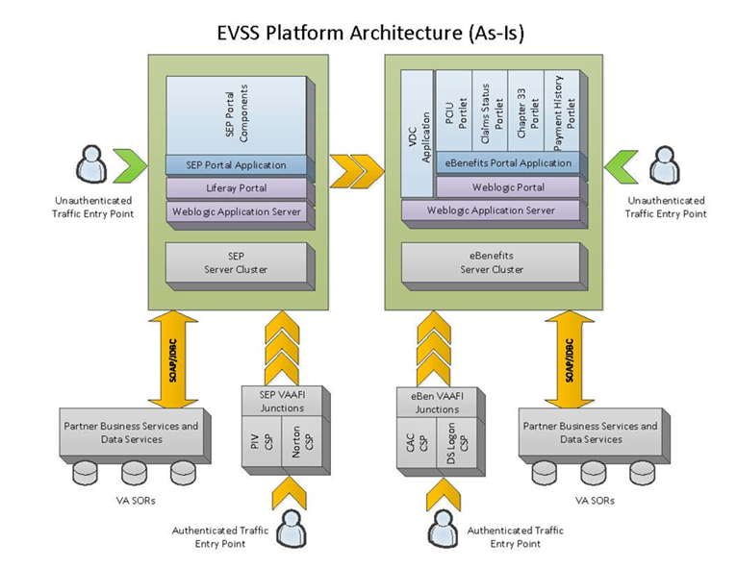

Figure As-Is Platform

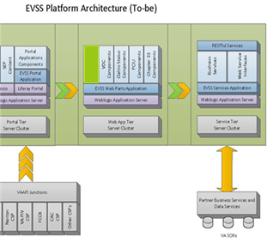

Figure To-Be Platform

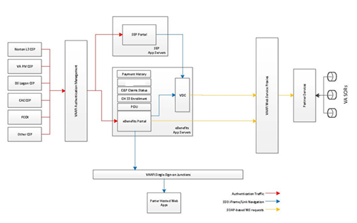

Figure To-Be State Diagram

# System Integrity Controls

## Characterization of the Information

The following questions are intended to define the scope of the information requested and/or collected as well as reasons for its collection as part of the EVSSP2.

### What information is collected, used, disseminated, or maintained in the system?

The EVSSP2 will construct a user profile utilizing both user provided information as well as authoritative data sources such as the DoD DEERS data repository and the VADIR system maintained by the VA.

The user will be asked to provide an email address to facilitate informing the user of updates to the portal and to allow for additional functionality when it becomes available.

The system will leverage the DoD DS Login service to provide the following information

* EDIPI (DoD specific attribute for authentication/identification)
* Sponsors’ EDIPI (DoD specific attribute for authentication/identification)

Additional information is provided by DS logon. However, this information is not used in the user profile and is not stored on the portal in any way.

The system will leverage the external data repositories to provide the following information.

The PII level is the level of sensitivity for a specific attribute and will be used to determine what information can be retrieved by the user in the event that the user is authenticated with a Level 1 credential. If a piece of data is classified as a Level 2 attribute, then only a Level 2 or greater credential can be used to retrieve the attribute.

Table : Data Attributes and PII

| Attribute | Source | PII Query Level |
| --- | --- | --- |
| Authenticated Person |  |  |
| DoD EDIPI | WebDEERS | 1 |
| Last Name | DEERS/User | 1 |
| First Name | DEERS/User | 1 |
| Middle Name | DEERS/User | 1 |
| SSN | WebDEERS | 2 |
| Sex Code | WebDEERS | 1 |
| DOB | WebDEERS | 2 |
| E-mail Address | User | 1 |
| Current Mailing Address |  | 2 |
| Line 1 | DEERS | 2 |
| Line 2 | DEERS | 2 |
| City Name | DEERS | 2 |
| State Code | DEERS | 2 |
| Country Code | DEERS/User | 2 |
| ZIP Code | DEERS/User | 2 |
| ZIP Code Extension | DEERS | 2 |
| Marital Status |  | 1 |
| Number of Dependents |  | 2 |
| Branch of Service | DEERS | 1 |
| Rank | DEERS | 1 |
| Tricare Region |  | 1 |
| Military Treatment Facility |  | 1 |
| VISN |  | 2 |
| VA Center |  | 1 |
| Active Duty Status |  | 2 |
| Retirement Status |  | 1 |
| Disability Status |  | 2 |
| Disability Rating |  | 2 |
| Priority Group (8 levels) |  |  |
| Health Status? |  | 2 |
| Diagnosis? |  | 2 |
| Death Calendar Date | DEERS | 2 |
| Period(s) of Service |  | 2 |
| Audience Segment (6 segments) | User |  |
| Family Member Information |  |  |
| Relationship | WebDEERS | 2 |
| First Name | WebDEERS | 2 |
| Last Name | WebDEERS | 2 |
| Personal ID (e.g. SSN) | WebDEERS | 2 |
| ID Type Code | WebDEERS | 2 |
| DoD EDIPI | WebDEERS | 2 |
| Preferences |  |  |
| Communication Method (i.e. mail, email) | User | 1 |
| Specific Alerts Opt In/Out | User | 1 |

The forms platform accesses data as required to help the user pre-fill any form field for which the VA already has values in the VA Corp / BIRLS databases. Additional information is provided entered by the user to correct or complement the data retrieved from the CorpDB.

The PII Level is the level of sensitivity for a specific attribute and is used to determine what information is available to the user. Only Level 2 (in-person verified) users have access to the forms platform, ensuring that no data is shown to an unauthorized user.

Access to the forms platform wizards is logged to an audit log ensuring that any data access can be traced.

### Why is the Information being collected?

The profile information is being collected to allow for the system to offer personalized content depending on the user’s position in the service life cycle and to allow for targeted content of interest to be provided to the user.

The information is also being collected to allow for the system to pre-populate forms that the user can submit to the VA for action (benefits request, status updates, etc.).

Regarding forms platform, the information collected is only used to fill forms and support the business automation for the processes defined in the forms platform wizards.

Data that is not required by the wizard is not collected.

### How is the information collected?

The information collected from DS Logon is provided when the user first registers with the site and uses the DoD DS Logon service.

The information provided from VADIR is imported real time into the users’ profiles when they set up their profiles for the EVSSP2 Portal.

The information collected from the DMDC WSDL for attribute retrieval is collected real time when the user sets his/her profile for the EVSSP2 Portal.

The user will be asked to provide an email address when he/she first logs in to the EVSSP2 Portal.

Regarding the forms platform, the information collected from corporate data stores is retrieved through the forms platform – VETSNET interfaces as defined above.

Additional information is collected directly from the user of forms platform.

### How will the information be checked for accuracy?

We will provide contact information for the system of record holders to allow users to update/correct any irregularities with their information. Once the information is updated with the system of record and is available and the user logs into the EVSSP2 Portal, the system updates the user’s profile to reflect the current/correct information.

The user will not be able to modify the information in his/her EVSSP2 profile if the source of the information is an external data source. EVSSP2 instead provides contact information for the system of record so that the user can correct any incorrect information.

The users of the system are DS Logon Level 2 users that are allowed to review their data and apply any corrections when that correction is supported by the business process.

## Privacy Impact Analysis

Given the amount and type of data collected, the following section discusses the risks identified and how they are mitigated:

The primary risk identified is the potential for identity theft. The information maintained and utilized represents a moderate level of risk for identity theft.

The primary risks are mitigated by the fact that only the user and user-delegated individuals are given access to users’ profile information. At no time is PII used in reporting and all access to profiles is monitored and audited on a regular basis.

The information is also protected as it is not stored in our system except in volatile memory and is not maintained in our database. After the user is finished with his/her session and logs out from the portal, the information is purged.

All PII data will be protected in accordance with federal guideline and policy as well as any applicable laws and mandates.

See the eBenefits PIA for more information:



## Uses of the Information

The following questions are intended to delineate the use of information and the accuracy of the data being used.

### Describe all the uses of information collected for the portal.

The primary use of profile information is the populating of forms on the user’s behalf; this reduces the amount of duplicate entries that the user will have to fill out.

First name, Middle initial, and Last name are used to personalize the user’s experience and to differentiate between two or more users who have similar information.

Service status is used to provide targeted information specific to the user’s position in the service live cycle.

Date of birth allows content to be focused around possible life events that the user may be preparing for and for age-specific medical information.

Branch of service allows the portal to recommend specific benefits that maybe provided for service specific Veteran service organizations, as well as target news that may be of interest to the service member.

E-mail address allows the user to receive updates about the portal and, when additional functionality is available, it will allow for the alerting of the user to changes in status.

### What types of tools are used to analyze data and what types of data may be produced?

The EVSSP2 Portal has the ability to generate reports on site metrics and system administration tasks as well as security audits for information access.

### If the system uses commercial or publicly available data please explain why and how it is used.

EVSSP2 does not use commercial or publicly available date on its user base. EVSSP2 leverages only systems of record for information and that information is stored in a user profile table in the EVSSP2 database.

## Data Retention

### What information is retained?

All user profile information is called on demand and is not stored inside the EVSSP2 Portal except in memory (Random Access Memory).

The user profile uses the DoD EDI as a unique identifier; this and email address is the only information that the profile will contain in physical memory (i.e., hard disk).

### How long is the information retained?

All user profile information is retained until the user initiates an account deletion. The information is maintained as per site policy until the specified time frame has elapsed and then the data is removed from the site and will not be accessible.

User data will be retained under the guidelines of RCS 10-1 (VA policy on data retention).

### Discuss the risks associated with the length of time data is retained and how those risks are mitigated.

The EVSSP2 will not store information about the user except in the respect with a unique identifier (DoD EDI and email address). This information is stored until the user initiates an account deletion.

## Incident Responses

AITC maintains an incident response capability that supplements the VA Program. AITC ensures an adequate program is in place, such that management receives early notification about a computer security incident, ascertains the facts of the situation, makes a damage assessment, determines a priority and a corrective strategy, allocates resources as necessary to ensure an adequate correction within the priority timeframe, assesses responsibility, prepares complete documentation, plans and implements a permanent correction, and modifies procedures or policy as appropriate. These procedures are outlined in the AITC Handbook 6500.04, Computer and Network Security Incident Response.

# EVSSP2 VSO Work Queue

## Introduction

This section of the SDD describes the High-Level design of EVSSP2 components that support the VSO Work Queue feature. This feature is only available via the SEP application.

## Scope

This SDD focuses on the new components built within the WSS framework to support the feature. The feature is accessed via an iFrame from the SEP application.

This SDD does not intend to define all the interfaces to external systems. There are ICDs available describing the interfaces provided by VDC, SEP, and BGS. This new feature does not provide any new services that are called by external systems. (other than via iFrame)

This SDD also does not include all the details on how iFrames are integrated into the EVSSP2 portal.

## Summary of Feature

The VSO Work Queue feature is primarily used by a VSO to retrieve a list of work items from the back-end system. Various criteria can be supplied by the VSO to narrow the results returned. Each work item contains details which can include a list of comments. For more details, consult the requirements document.

## Major Components

### Web parts

This includes the JavaScript, FreeMarker 2.3.20, and Java controller sub-components. JavaScript provides the UI component interaction, form validation, modal pop-ups, and AJAX calls to back-end services. The FreeMarker 2.3.20 templates generate the HTML and perform simple logic such as looping through data for display. The Java controller coordinates the flow between the search entry screen and the results screen. The controller is also responsible for calling the back-end service to get the search results and details.

### Services

The following services are required: a search work items service, a work item comment count service, and a work item detail service. The search work items service calls a web service provided by BGS that returns a list of work items. The work item comment count service calls a REST service provided by VDC that returns the number of comments attached to a list of particular work items. The work item detail service calls a REST service provided by VDC that returns the actual comments associated with one particular work item.

### VSO Work Queue

#### Overview

Displays a screen that allows the VSO to enter criteria such as Veterans Service Organization, Application Status, Terminal Digits, and Location and submit a search.

Direct URL:

/mvc/vsoWorkQueueSearchEntry

***JavaScript 5.1:***

* Enables/disables the submit button based on if required criteria have been selected
* Dynamically changes location criteria based on the location type (i.e. Domestic, Military, etc.)
* Clears the form if the clear button is pressed
* Allows only valid terminal digit ranges

***FreeMarker 2.3.20:***

* Generates the entry page HTML.

***Controller:***

* Calls the user profile service to get information about the VSO currently logged in
* Populates the FreeMarker model with the VSO information and select box data

### VSO Work Queue Search Results

#### Overview

A screen is displayed that contains the search criteria again and the search results. The results show some details about the work item and the number of comments attached to the work item. A work item can be selected and the detail for that work item appears in a modal pop-up. The pop-up includes all the comments attached to that particular item.

Direct URL:

/mvc/vsoWorkQueueSearchResults

***JavaScript 5.1:***

* Calls the REST service in the services tier to get the number of comments attached to each visible work item
* Calls the REST service in the services tier to get the comments attached to the selected work item
* Handles sorting/pagination of results
* Displays/cancels the detail pop-up page
* Builds a JSON string containing the work item data in order to populate the detail page

***FreeMarker 2.3.20:***

* Generates the search results HTML
* Loops through the work items in the model
* Populates JavaScript variables for JSON data and REST URLs

***Controller:***

* Calls the user profile service to get information about the VSO currently logged in
* Calls the work items service in the service tier to get all the work items matching the given criteria
* Populates the FreeMarker 2.3.20 model with the VSO information, select box data, search criteria selected, the work items, and the REST URLs

### BGS Work Queue Web Service

BGS is providing a SOAP web service endpoint for retrieving work items (non-submitted 526s) based on user-selected criteria. The request and response objects should be generated per the WSDL and XSDs outlined in Appendix A. The following describes the request and response between SEP and BGS.

***Request:***

The request contains the search criteria selected by the user. This includes a list of POA codes, statuses, locations (U.S. States, countries, military post offices, and military postal codes) as well as a range of terminal digits (the last 2 digits of the Veterans’ file number). In addition to the user-selected criteria, the participant ID and sensitivity level of the VSO are also included.

Note: The sensitivity level will not actually be used. BGS will internally verify that the VSO has the appropriate sensitivity level based on the participant ID. Also note that although the artifacts state that all elements are optional, the reality is that the following will be required: POA code, participant ID, and sensitivity level. Furthermore, terminal digits may also be required in order to ensure that the request does not time out.

The generated request object and its related objects need to be populated from EVSSP2 search work item transfer objects before making the SOAP request.

The following objects and values are part of the request object ReadVSOWorkQueue:

* PoaCodeListVO – POA Code (String List)
* StateListVO – State (String List)
* CountryListVO – Country (String List)
* MilitaryPOListVO – Military Post Office (String List)
* MilitaryPostalCodeListVO – Military Postal Code (String List)
* ProcStatusListVO – Status (String List)
* TerminalDigitNumberListVO – Terminal digit (String List)
* poaRepParticipantID – VSO participant ID (Long)
* poaRepSensitivityLevel – VSO sensitivity level (String)

***Response:***

The response contains a list of work items that meet the criteria sent in the request. Each work item contains String values for the process (work item), the Veteran, and the VSO. Only the values that are needed by EVSSP2 are described below.

The values from the generated response object and its related objects need to be transferred to the EVSSP2 work item transfer objects before returning the data.

The response object ReadVSOWorkQueueResponse is made up of a List of VsoWorkQueueReturnVO, defined as:

* procID – the unique identifier of the work item (Long)
* procStatus – the status of the work item (String)
* procType – the type of work item (String)
* dateRequestActioned- the Date that the work item was last updated (XML Calendar)
* dateRequestExpires – the Date that the work item expires (XML Calendar)
* dateRequestReceived – the Date that the work item was entered (XML Calendar)
* vetFirstName – the Veteran’s first name (String)
* vetLastName – the Veteran’s last name (String)
* vetMiddleName – the Veteran’s middle name (String)
* socialSecurityNumber – the Veteran’s SSN (String)
* fileNumber – the Veteran’s file number (String)
* addressLineOne – the Veteran’s first address line (String)
* addressLineTwo – the Veteran’s second address line (String)
* city – the Veteran’s city (String)
* state – the Veteran’s state (String)
* zip – the Veteran’s zip (String)
* country – the Veteran’s country (String)
* militaryPO – the Veteran’s military post office (String)
* militaryPostalCode – the Veteran’s military postal code (String)
* vsoName – the work item VSO/POA name (String)
* vsoUserEmail – the VSO’s email address (String)

### VDC Work Queue Web Service

VDC is providing REST web service endpoints for retrieving work item comment counts based on a list of work item IDs, and for retrieving work item details (comment list and status history) based on a work item ID. Request and response objects should be manually created but should match the objects generated per the XSDs. The following subsections describe the request and response between SEP and VDC.

#### Comment Count Request

The comment count request contains a list of work item IDs (procID), as well as information about the VSO which is used for auditing. A list of work item IDs will be sent (10 at a time) via an Ajax call in order to maximize performance. No additional transformations between EVSSP2 and VDC objects need to occur.

The following values are part of the request object GetCommentCountRequest:

* agentUserID– the VSO user ID (Long)
* agentCorpParticipantID– the VSO participant ID (Long)
* procIDList– the list of work item IDs (String Long)

#### Comment Count Response

The comment count response contains a list of comment count objects (WorkItemCommentCount) corresponding to the requested procIDs. The response object GetCommentCountResponse is made up of a List of comment count objects (WorkItemCommentCount), defined as:

* procID – the unique identifier of the work item (Long)
* commentCount– the number of comments for the work item (Integer)

#### Work Item Detail Request

The work item detail request contains a single work item ID (procID), as well as information about the VSO which is used for auditing. No additional transformations between EVSSP2 and VDC objects need to occur.

The following values are part of the request object GetWorkItemDetailRequest:

* agentUserID– the VSO user ID (Long)
* agentCorpParticipantID– the VSO participant ID (Long)
* procIDList– the list of work item IDs (String Long)

#### Work Item Detail Response

The work item detail response contains a work item detail object (WorkItemDetail) corresponding to the requested procID. The response object GetWorkItemDetailResponse is made up of a work item detail object (WorkItemDetail), defined as:

* comments – a list of comments (CommentHistoryItem List)
* statusHistory – a list of statuses (StatusHistoryItem List)

Note: the Status History is not being used by EVSSP2 but was added to be consistent with VDC. No further details of this object will be given.

A CommentHistoryItem is defined as:

* commentText – the comment (String)
* commentTime – the date and time of the comment (Date)
* userID – the commenter user ID (Long)
* userParticipantID – the commenter participant ID (Long)
* userFirstName – the commenter first name (String)
* userMiddleName – the commenter middle name (String)
* userLastName – the commenter last name (String)
* userRole – the commenter role (RoleType)
* poaCode – the commenter POA code (String)

The work item detail response contains a work item detail object (WorkItemDetail) corresponding to the requested procID. The response object GetWorkItemDetailResponse is made up of a work item detail object (WorkItemDetail), defined as:

* comments – a list of comments (CommentHistoryItem List)
* statusHistory – a list of statuses (StatusHistoryItem List)

**Note:** the Status History is not being used by EVSSP2 but was added to be consistent with VDC. No further details of this object will be given.

A CommentHistoryItem is defined as:

* commentText – the comment (String)
* commentTime – the date and time of the comment (Date)
* userID – the commenter user ID (Long)
* userParticipantID – the commenter participant ID (Long)
* userFirstName – the commenter first name (String)
* userMiddleName – the commenter middle name (String)
* userLastName – the commenter last name (String)
* userRole – the commenter role (RoleType)
* poaCode – the commenter POA code (String)

#### EVSSP2 VSO Work Queue Design Diagrams

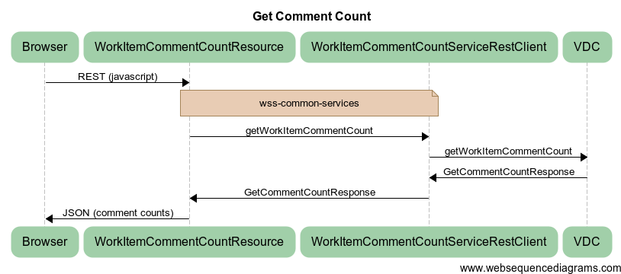

Figure : Get Comment Count Sequence Diagram

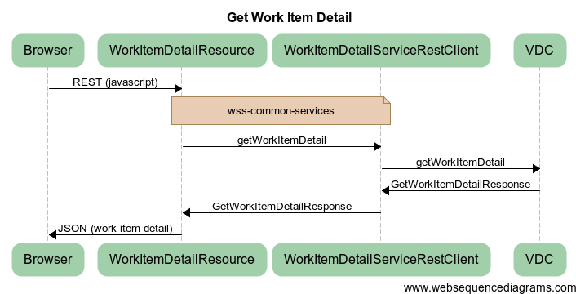

Figure : Get Work Item Detail Sequence Diagram

The following diagram represents the To-Be state of Platform Consolidation.

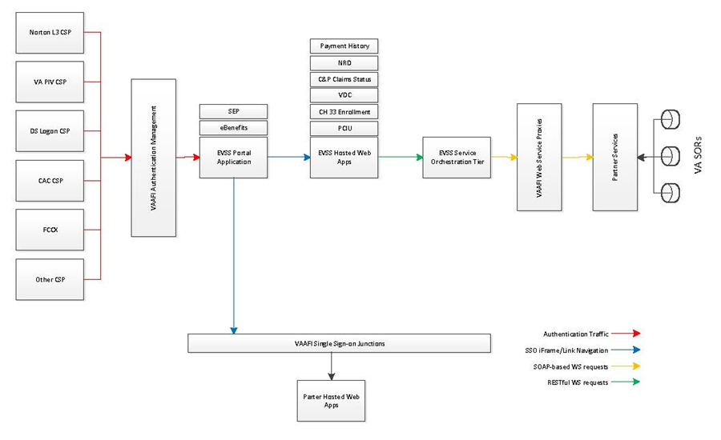

1. Additional Information
   1. Requirements Traceability Matrix (RTM)

The Requirements Traceability Matrix is located and maintained on the EVSSP2 Rational Team server at URL <https://clm.rational.oit.va.gov/ccm/web/projects/EVSS%20(CM)>.

* 1. Packaging and Installation

Packaging and installation do not apply for this SDD.

* 1. Design Metrics

Design metrics do not apply for this SDD.

* 1. Glossary of Terms

Table : Glossary of Terms

| Term | Definition |
| --- | --- |
| AITC | Austin Information Technology Center |
| ATO | Authorization to Operate |
| BDN | Benefits Delivery Network |
| BIRLS | Beneficiary Identification and Records Locator System |
| BVA | Board of Veterans’ Appeals |
| CAC | Common Access Card |
| C&P | Compensation and Pension |
| CDB | Central Database |
| CHAMPVA | Civilian Health and Medical Program of the VA |
| CMS | Content Management Services |
| CONOPS | Concept of Operations |
| CSID | CSP Identifier |
| CSP | Credential Service Provider |
| DBMS | Database management system |
| DEERS | Defense Enrollment and Eligibility Reporting System |
| DMDC | Defense Manpower Data Center |
| DNS | Domain Name Server/System |
| DoD | Department of Defense |
| EBN | eBenefits |
| ECMS | Electronic Contract Management System |
| EDIPI | Electronic Data Interchange Personal Identifier |
| EHR | Electronic Health Record |
| EIT | Electronic and Information Technology |
| EVSSP2 | Enterprise Veterans Self Service Phase 2 |
| FIRP | Federal Individual Recovery Plan |
| FISMA | Federal Information Security Management Act |
| FRC | Family Resource Center |
| FRD | Functional Requirements Document |
| HIE | Health Information Exchange |
| HTTPS | Hypertext Transfer Protocol Secure |
| IAM | Identity and Access Management |
| iAS | Identity Authentication Service |
| ICN | Integration Control Number |
| ISCP | Information System Contingency Plan |
| IT | Information Technology |
| J2EE | Java™ Enterprise Edition |
| JDBC | Java Database Connectivity |
| JSON | JavaScript Serialized Object Notation |
| JSR | Java Specification Request |
| LAN | Local access network |
| LOB | Lines of Business |
| LDAP | Lightweight Directory Access Protocol |
| MHS | Military Health System |
| MOU | Memorandum of Understanding |
| MTF | Military Treatment Facility |
| MTP | Master Test Plan |
| MTTR | Mean time to repair |
| NHIN | Nationwide Health Information Network |
| NIST | National Institute of Standards and Technology |
| OIT | Information and Technology |
| PD | Product Development |
| PII | Personally Identifiable Information |
| PIA | Privacy Impact Assessment |
| PIV | Personal Identity Verification |
| PMP | Project Management Plan |
| PWS | Performance Work Statement |
| RAAWS | Recommender Agents and Adaptive Web-based Systems |
| REST | Representational State Transfer |
| ROI | Release of Information |
| RPO | Recovery Point Objective |
| RSD | Requirements Specification Document |
| RTM | Requirements Traceability Matrix |
| RTO | Recovery Time Objective |
| SAML | Security Assertion Markup Language |
| SDD | System Design Document |
| SEP | Stakeholder Enterprise Portal |
| SOA | Service Oriented Architecture |
| SOAP | Simple Object Access Protocol |
| SSA | Social Security Administration |
| SSL | Secure Socket Layer |
| SSN | Social Security Number |
| SSO | Single Sign-On |
| TBD | To be determined |
| TRM | Technical Reference Model |
| TSPR | Technical Services Project Repository |
| VA | Department of Veterans Affairs |
| VAAFI | VA Authentication Federation Infrastructure |
| VAPii | VAP Interface Improvements |
| VBA | Veterans Benefits Administration |
| VDC | Veterans On Line Application (VONAPP) Direct Connect |
| VETS | Veterans Service |
| VETSNET | Veterans Network |
| VHA | Veterans Health Administration |
| VI | U.S. Virgin Islands |
| VIP | Veterans Information Portal |
| VONAPP | Veterans On Line Application |
| VRM | Veterans Relationship Management |
| VSO | Veteran Service Organization |
| VVA | Virtual VA |
| WSRP | Web Services for Remote Portals |
| WSS | Web Self Service |

1. Source: EVSSP2 Component High Level Design, Ironworks.
2. Source: EVSSP2 Project Charter, 3/2011
3. Source: 20110415_HPTi_VRM SS FORMS PLATFORM II SDD Informational Interview.doc
4. Source, Section 2.1: FORMS PLATFORM website.
5. Source, Section 2.5.5: FORMS PLATFORM System Architecture created by BearingPoint for the previous FORMS PLATFORM project.
6. Source: EVSSP2 Portal Platform and Network Architecture (June 9, 2010).
7. Source: 20110415_HPTi_VRM SS FORMS PLATFORM II SDD Informational Interview.doc
8. Source: EVSSP2 Portal Platform and Network Architecture (June 9, 2010).
9. Source: 20110415_HPTi_VRM SS FORMS PLATFORM II SDD Informational Interview.doc